**TRANSGENDERS IN INDIA: ISSUES AN CHALLENGES**

**Introduction**

Transgender people are individuals of any age or sex whose appearance, personal characteristics, or behaviours differ from stereotypes about how men and women are ‘supposed’ to be.  **Transgender** or **Trans**: means someone whose gender differs from the one they were given when they were born.  Transgender people may identify as male or female, or they may feel that neither label fits themIn India, the transgender community, the most marginalised community still struggles for acceptance and development partly due to the usual gender identity crises that they face, (considering *hijras* and transgenders as women, or as a third sex (if they want it) and the unequal treatment in terms of access to human development that eventually deprives them from several rights. These rights include the right to vote, the right to own property, the right to marry, the right to education, employment, health, and so on. Such deprivation secludes the transgenders from the very fabric of Indian civil society and hence is left behind.

Coupled with this constant struggle for recognition and acceptance can be traced back to initial experience with the family. Several theories like The Parental Acceptance–Rejection (PAR) theory successfully indicate that a child's experience of rejection may have a significant impact on their adult lives. In some cases, there is evidence of domestic violence at the hands of a family member because of their identity. Families who do accept their identities might put many restrictions in order to hide the reality from the world. While only some are able to manage to fight the exclusion, many lives end in depression and isolation.

Given this context, the present article attempts to provide a brief picture of the historical, social and legal landscapes that have shaped the lives of transgenders in India. Starting with highlighting the colonial genesis of discrimination towards transgenders in India, the article goes on to examine the current social and legal challenges that the transgender community in India faces today. The article finally suggests some measures that the state should adopt to bring transgenders from the fringes of socio-economic growth to the centre.

**Historical Picture**

**Historical Picture**

Scholarly evidence highlights that historically in India the social boundaries that divided transgenders from the non-transgenders were either blurred or missing. For instance, as Nanda (1999: 23) argues, Islam in India has historically provided a model of an “in-between gender” – which is not mythological, but “a true historical figure.” During the Delhi Sultanate and the Indian Mughal Empire, eunuchs served as confidants, political advisors, *darwans*,and guardians of the harem.[1] The *hijras* also played a prominent role in the narratives of ancient Hindu mythology. In the epic *Ramayana*, Rama gifted the *hijras* the power to confer blessings on people on auspicious occasions like childbirth and marriage.[2] According to Vanita, Puranic stories, such as that narrating the sex change of devotees such as Narada and Arjuna, highlight that in Hindu mythology, “gender, like the body itself, is seen as a garment, a disguise ... and is not rigid and unchangeable, nor does it fully determine the self.”[3] Similar readings from literature and history indicate towards the prevalence of a vast degree of gender fluidity in the Indian subcontinent.

However, many have argued that after the advent of British rule, as the colonial state expanded, so did the sexual/gender dichotomy that was established in the West and was historically alien to India. As Vanitha and Kidwai note, the British raj marked a “transitional phase” in the Indian society where “older indigenous discourses of same-sex love and romantic friendship came into dialog with the new Western legal and medical discourses of homosexuality as an abnormality or an illness.”[4] This association of homosexuality with deviance was concomitant with legal interventions by the colonial state that penalised all non-heterosexual modes of living. Both section 377 of the Indian Penal Code and the 1897 amendment to the Criminal Tribes Act, 1871 solidified the link between sexual non-conformity with criminality. Under the amendment, subtitled ‘An Act for the Registration of Criminal Tribes and Eunuchs,’ the local government was required to keep “a register of the names and residences of all eunuchs residing in any town or place ... who are reasonably suspected of kidnapping or castrating children or commenting offences under section 377 of the IPC” (Patni, 2011: 297).[5] It is pertinent to note that the colonial policing of transgenders was not only restricted to their sexual lives; even their social lives were rendered illegal, since the amendment decreed eunuchs as “incapable of acting as a guardian, making a gift, drawing up a will or adopting a son” (ibid).

**The Current Social Context**

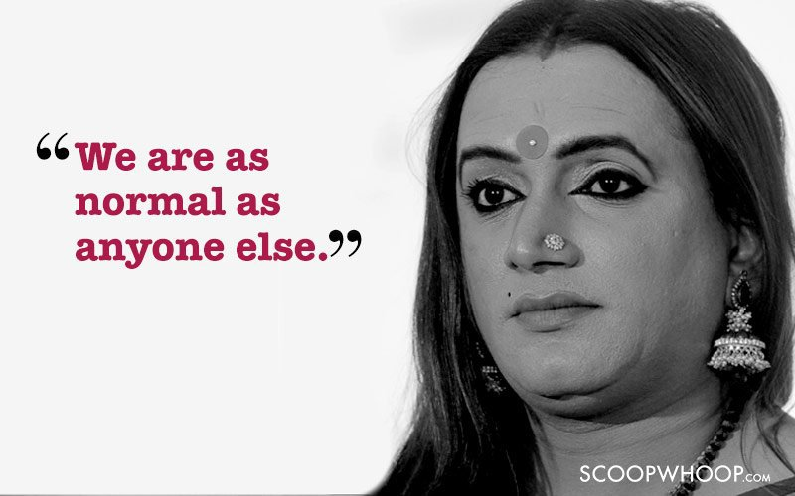

The legal norms established by almost a century of colonial rule continue to find their way into the social landscape of post-colonial India. Section 377, earlier repealed in 2009 but reinstated in 2013, stays firmly in place as ‘constitutional.’ In such a scenario, the landmark judgment by the Supreme Court in 2014 that created the third gender status for *hijras* and transgenders was seen as major sign of relief, as it was the first time that the third gender had got a formal recognition. But after three years of the landmark judgment, there is evidence of constant struggle. While most of them still continue to lead their life by dancing and singing, some earn their livelihood by begging or prostitution. Despite efforts, the third gender is still considered to be at lowest rung of the society. This category is largely subjected to extreme discrimination in every field of life whether it is health, employment, education, sexuality or social acceptability.

***“While this is really encouraging it will take time before there is some noticeable change. There are thousands who still get the boot from the family and society. Maybe a few have finally started realising that we too are human beings who deserve an equal life,” Kalki Subramaniam***

In the field of education, no formal education for transgender is popular in the Indian context. Since they are deprived from the family and school environment, they drop out from their education and run away from the family risking their future career opportunities. This is mainly because of the stigma and discrimination attached. As a result, they are left with fewer opportunities as compared to others. In terms of employment, The Universal Declaration of Human Rights asserts the rights of individuals to work at the job of their choice, receiving equal pay for equal work, without discrimination. Yet far too often, transgender people are denied these basic human rights.

***“Access to education and consequently to employment continue to evade the transgender community. Transpeople continue to face the violation of their right to life, facing unreported and unregistered hate crimes. There is very poor access to health and medical care, and many transpeople continue to be pathologised as having ‘gender identity disorder’ due to inaction by the Medical Council of India.” -***Vyjayanti Vasanta Mogli, Transgender Activist

They also experience discrimination when accessing health care, and are subject to disrespect and harassment (sometimes leading to violence) and outright denial of service. Whether seeking preventive medicine or transgender related services, including counselling and hormone replacement therapy, access to appropriate restroom facilities, knowledge and accessibility of contraception and the lack of provision of separate wards for transgender person’s basic healthcare is an unachieved journey. The hijras/TG communities also face several sexual health issues including HIV. Personal- and contextual- level factors which influence their sexual health condition.

***“The biggest lacuna in the system is that nobody knows the real definition of a transgender. Sensitisation will not help until people are ready to accept change and acceptance can come only through education.” -*** Manabi Bandopadhyay

**Legal Challenges**

Legal issues can be complex for transgender or intersex people. The struggle begins with their fight for gender identity. The legal system of the country has entrenched the marginalisation and stigma of this community by failing to provide them their basic civil and human rights. It has perpetuated transphobia and encouraged the notion that they are ‘not normal’. Despite international obligations towards basic human rights and non discrimination, the transgender community continues to be at risk with constant violation of their rights and dignity. Their status as the third gender, although legally recognised by the Supreme Court in its 2014 judgment, finds little relevance in everyday life since there has been no concrete law enacted to implement the same. The Bill tabled by the Ministry of Social Justice in 2016 reflects apathy and ignorance towards the problems faced by this community and a general lack of understanding of their group dynamics. Even though attempts by the Parliament at enacting laws for protection of transgender rights have sought to address offences against them and curb all instances of discrimination, it has always fallen short of the required tenacity to implement them. The bill reflects the complacent attitude adopted by the legislature towards serious crimes committed against transgenders and the reluctance to address them at a comprehensive level. The laws of the country, especially gender specific laws do not specify a third gender which creates a limbo as far as rights of transgenders are concerned. Laws like IPC and personal laws including family matters do not have the provisions to include a third gender and thus, it is unclear as to the redressal available in case of sexual offences against transgenders or even matters of marriage and divorce. Another major obstacle in the way of realisation of rights of this community is Section 377 of IPC which criminalises same sex relationships and forces them to live in a criminalised context. It makes it difficult to approach the law in case of any sexual assault against them and subjects them to brutal police conduct. In the most fundamental sense, it is a denial by the state of a person’s basic civil and political rights as is enshrined in all international human rights laws. But any debate along the lines of repealing or amending it has been deftly avoided by the government while the judiciary also looked away. Under these circumstances, it is impossible to bring about any meaningful change in the lives of this community. These crucial impediments must be eliminated so that it can pave a road towards constructive dialogue and framing an effective law.

Although a legal development in this field will be huge leap forward, it is only when the underlying issues of transphobia and social isolation are addressed will there be a tangible change. Apart from the challenges that transgenders face from the society, there are also allegations at times of ring leaders, who controls sex work as well as organised begging not allowing benefits to reach the targeted group. These are roadblocks that are often neglected by the lawmakers while drafting a law thus limiting its effectivity. It is essential that group dynamics within the community as well with the mainstream society is understood by the law makers to ensure that it is tune with ground realities. For this, it is necessary to engage community leaders as well as members of civil society so that the benefits can permeate to the lowest strata. A combination of both social transformation coupled with legal protection is the only way to ensure that there is genuine transformation in the lives of these communities.

**Way Forward**

The current environment of isolation, exclusion and prejudice that is inherent to a transgender’s life is a confluence of several factors arising from the heart of the society. Addressing the root of the problem will involve tackling the mindset of the people which is rooted in deep seated prejudice against this community. However, their rights and liberty cannot be subject to society’s approval and the State should intervene to bring about progressive changes and safeguard dignity. There are several measures that the state can take apart from introducing statutory protection. Some of the suggestions that have been frequently made to ameliorate them with the mainstream society are-

* Provision of gender neutral zones in public spaces – such as restrooms, frisking zones at places of transit, trial-rooms, etc.
* Provision for penalising abortions of intersex foeticide
* Providing exclusive HIV zero surveillance centres for transgenders
* Career guidance as well as counseling services to deal with trauma and violence should be provided.
* Employment opportunities with reservation for transgenders as a backward class as directed by the Supreme Court in the NALSA judgment
* The repeal of Section 377 from the IPC

These are small steps that will enable the transgender community to gradually overcome the trauma and stigma that long term deprivation has caused and with better economic opportunities, the risk of forced prostitution and beggary also reduces. This country and its society has a long way to go before it can completely remove the bias it has against transgenders but the legislature and the judiciary should continuously aim toward progressive measures and not be influenced by prevailing prejudices.

1. **References**

   Iyer, N. (1999). Hijra/Hejira. In Jodi Brien (Ed.), *Encyclopaedia of Gender and Society, Volume 1 and 2* (p. 421). California: SAGE Publications.
2. Garud, R. & Tharchen,T. (2017). The Performative Puzzle: How Institutions Matter in Marginalizing and Reconstructing Identites. In Joel Gehman, Michael Lounsbury, & Royston Greenwood (Eds.), *How Institutions Matter!* (p. 250). Bingley: Emerald Group Publishing Limited.
3. Vanita, R. (2000). Introduction: Medieval Materials in the Sanskritic Tradition. In Ruth Vanita and Saleem Kidwai (Eds.), *Same-Sex Love in India: Readings in Indian Literature* (p. 65). New York: Palgrave
4. Vanita, R. & Kidwai, S. (2000). Introduction: Modern Indian Materials. In Ruth Vanita and Saleem Kidwai (Eds.), *Same-Sex Love in India: Readings from Literature and History* (p. 196)*.* New York: Palgrave
5. Patni, T. (2011). Transgender – A Stigma on the Society by the Society. In K. Jaishankar & Natti Ronel (Eds.), *First International Conference of the South Asian Society of Criminology and Victimology: Conference Proceedings* (p. 297). Tirunelveli: SASCV & Department of Criminology & Criminal Justice, Manonmaniam Sundaranar University.