PROXY VOTING IN INDIA

The Government’s Stand

* The Union Cabinet on Wednesday cleared a proposal to extend proxy voting to overseas Indians by amending electoral laws.
* For overseas Indians, the Representation of the People Act needs to be amended to include proxy voting as other means to cast their votes. The following amendments will be required under the RPA 1951 which was last amended in the year 2010 by introducing section 20A. This section made special provisions for every citizen of India residing outside the country to enrol them electors provided they had not acquired the citizenship of any other country and were otherwise eligible to be registered as a voter. Apart from that, sections 50 and 60.
* For Conduct of Elections Rules 1961: Amendment needed in sections 17 (postal ballot), 18, 19, 20 (1) & (2), 22, 21 (1), (2), (3) and from 23-27 will be required.
* As per the procedure, the elector must first register as a voter, following which he has to appoint a proxy who must be a registered voter in the elector’s constituency. Once that is done, the elector can inform the proxy of who he wants to vote for.
* Non-Resident Indians will have to nominate one proxy for each poll.
* Another option would be to use postal ballots delivered to them by electronic means to cast their votes. This would mean amending the current laws governing the right to vote.
* An expert committee in the Election Commission working on the issue had, in 2015, forwarded the legal framework to the law ministry to amend electoral laws to allow overseas Indians use proxy voting. Going by the data that shows only 10,000 to 12,000 NRIs have voted because they do not want to spend foreign currency to come to India and exercise their franchise.

Statistics presented by the Election Commission regarding Proxy Voting:

The issue of proxy voting for NRIs came up in public interest litigation in the Supreme Court in 2014. The Supreme Court asked the EC to initiate a committee to examine the proposal, following which the Committee for Exploring Feasibility of Alternative Options for Voting by Overseas Electors was set up. The EC looked at existing systems across the world and shortlisted four possible ones: voting in embassies, online voting, postal or e-postal ballot and proxy voting.

The committee observed that the proxy voting facility would be a “convenient, efficacious and doable method” of providing voting facility to overseas electors. Since the appointment of the proxy can be made at any point of time, the issue of time constraint, the logistical issues of voting in the embassies and the related issue of seeking the host country’s permission were completely eliminated. The load on the returning officer and the election machinery would also be considerably less.

* Out of the total 11,846 registered overseas electors, as of **January 2014**,11,448 (96.64%) are registered in the State of Kerala and the rest 398 (3.36%) are registered in the States of Punjab (138), Tamil Nadu (112) Puducherry (56), Goa (27), Delhi (13), Haryana (12), Daman & Diu (9), Gujarat (7), Chandigarh & Madhya Pradesh (6 each), West Bengal (4), Chhattisgarh & Himachal Pradesh (2 each), and Andhra Pradesh, Rajasthan, Sikkim, Uttar Pradesh (1 each) but only 8 came ahead and voted.
* At present 24,000 overseas Indians, who are entitled to cast their ballot in India, have registered themselves as voters. While there are no estimates on the number of overseas Indians eligible to vote in India, only 24,348 have registered with the poll panel. Out of these, 23,556 are from Kerala, 364 from Punjab and 14 from Gujarat, according to the data provided by the Commission.

MIGRATION: The Indian Diaspora across the World

1. Pakistan, which is India’s neighbour and political rival, records the second-highest number of Indian-born people outside of India, at **2**million, according to the U.N. data.
2. In terms of numbers, the U.S. is still the second-most popular destination for Indians, with nearly 2 million people who were born in India living there.
3. Numbers of Indian immigrants in the U.A.E. have also slowed dramatically in the past five years, rising only 20% from 2010 to 2015 compared with an increase of 126% between 2005 and 2010. The number of Indian men choosing to live abroad rose 18% from 8.5 million in 2010. The number of women doing the same thing rose 15% from 4.8 million in 2010 to 5.5 million in 2015.

Recent Trends

* The leading Indian states for outward labour migration, in 2014, included Uttar Pradesh, Bihar, Tamil Nadu, Kerala, Andhra Pradesh, West Bengal, Punjab, and Rajasthan. Together, these states accounted for over 80% of the migration from India at 678,644 outward migrants.
* Uttar Pradesh was the top contributor at 230,000 outward migrants showing a new trend of decrease in the rate of presence of the Keralites in GCC as compared to 2014 report. Bihar is at the second position to send out workers to these countries. GCC continues to dominate as the preferred location for un-skilled and semi- skilled labourers. Eg, Saudi Arabia was the most popular destination for Indian migrants in 2015, with a total of 2.8 million Indians migrating to the country, due to ease of availability of jobs to unskilled labour along with higher wages compared with India.
* There is a recent increase in the rate of migration taking place in India itself that is migration of labourers from north to south India.

***So which countries do the labourers migrate to?***

* The states of Uttar Pradesh, Bihar, Haryana and Rajasthan accounted for over 370,000 emigration clearances in 2014. Bulk of these clearances was for the Middle East region. The migrants from these states are majorly unskilled and engage in jobs in the construction and retail industry
* The states of Kerala, Andhra Pradesh, Telangana, and Tamil Nadu accounted for over 240,000 emigration clearances in 2014. Bulk of these clearances was for the EU, Australia, US, and the Middle East. The migrants from these states are majorly semi-skilled and engage in jobs in the healthcare, retail, and manufacturing industry.
* The states of Maharashtra and Karnataka accounted for over 34,000 emigration clearances in 2014. Bulk of these clearances was for EU and the US. The migrants from these states are majorly skilled and take up jobs in the information technology industry.
* The states of Gujarat and Punjab accounted for over 56,000 emigration clearances in 2014. Bulk of these clearances were for the US, Australia, Malaysia, and Singapore. The migrants from these states are majorly entrepreneurs, looking to move to other countries to set up their businesses.
* The states of West Bengal, Odisha, and North East India accounted for over 70,000 emigration clearances. Bulk of these clearances was for the Middle East, Australia, Singapore, and Malaysia. The migrants from these states are majorly semi-skilled and engage in jobs in the hospitality and retail industry.

There are approximately 10 million Indian citizens currently residing outside India as per the data compiled by the Ministry of External Affairs. These numbers have the potential to affect the election results if NRIs do vote in large numbers. With 10 million Indian citizens staying abroad, and with 543 Lok Sabha constituencies, it comes to an average of 18000 such voters per constituency. These additional votes, if polled, will have a significant impact on the result. Kerala, Punjab and Gujarat are three States that have a major expatriate population and the experiment would have a great bearing on the election process in these States. The Centre would also have to take the State governments into confidence before going ahead with the process.

Thus, proxy voting in India if it happens will have a huge impact on the elections because of a large majority of migrants in GCC.

|  |  |
| --- | --- |
| Education | Largely less educated, relatively young and unmarried. They normally come from rural and comparatively poor economic background. |
| Employment | Largely unskilled labour employed in construction companies, municipalities agricultural farms domestic workers and as housemaid; skilled and semi-skilled workers employed as craftsman, driver, artisan and other technical workers; white-collar or professionals such as doctors, engineers, accountants, nurses, and paramedics, employed in government, private sectors and entrepreneurs. Although recent trends show return of a large number of Malyalis back to the native state to invest in their own state and family. Indian workers emigrating to 6 Gulf nations declines by 34.6%, remittances fall. |
| Political Views | Workers are politically very much interested in Indian politics. According the many leaders of the Labour Union in GCC claim that the workers face hard time to register online at the Election Commission website since the passports are usually seized by the employees. It s not feasible for the workers to travel especially for voting |
| Demands if any | * Exploitation by employers, unregulated private recruitment agencies involving in malpractices, and resultant increase in illegal migration. The average NRI death toll in the six Gulf countries (69.2 per 100,000) is much higher than in the rest of the world. The possible reason stated is that Indians living in the West generally work in the technology and financial sectors (whereas most Indians go to the Gulf nations to work in high-risk jobs such as construction). |
| Views on Proxy Voting | A cross-section of Indian expatriates in the UAE welcomed Indian Government’s decision to give Non-Resident Indians (NRIs) the right to vote from abroad in elections in India through proxy voting but instead of majority of people consider postal ballet as a better option to promote regular voting patterns apart from the fact they are happy that they will be able to participate in the Indian elections. They also demand aadhar linked identification code for easy e-voting. |

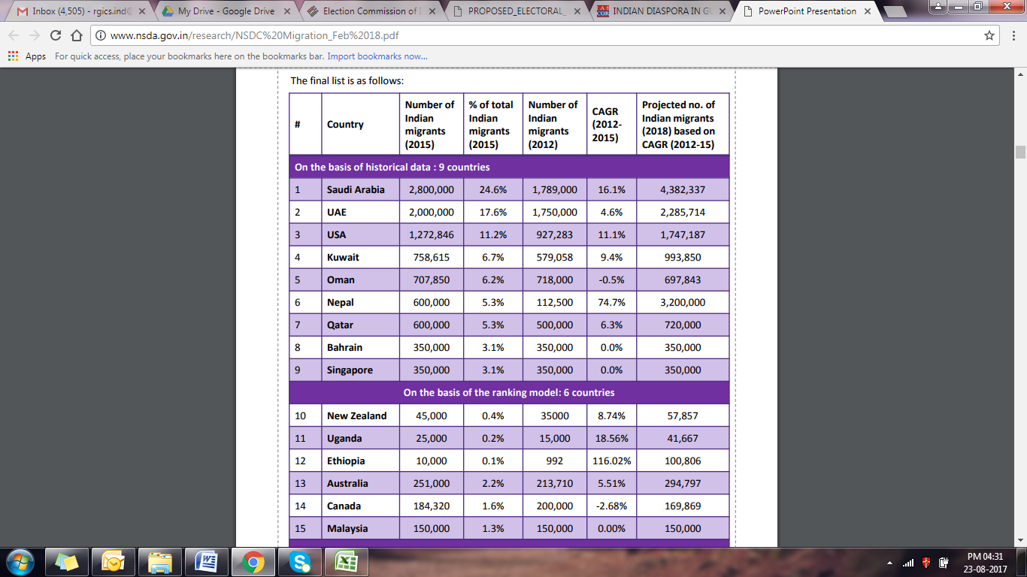

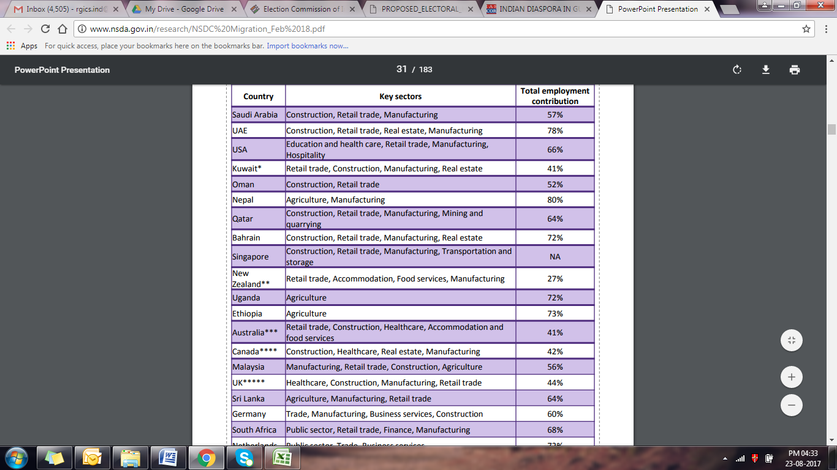

* If proxy voting happens in India, this move is likely to have a huge impact on elections in states like Kerala, a highly politicised community which has nearly 10% of its population living abroad, 98% of registered overseas voters helping its economy sustain through remittances but having no say in elections.

For example, Kuttiadi, for long a fortress of the Communist Party of India (Marxist), produced the biggest surprise of the 2016 Assembly election when Parakkal Abdullah, of the Indian Union Muslim League, won the seat by a thin margin of 1,157 votes. The possible reason for his massive win could be Gulf-based voters who helped win who flew down on Election Day to cast votes. The expected constituencies that would be affected are: Nadapuram (CPM), Perambra (CPM), Kuttiadi (IUML), Palakkad (INC) and Varkala (CPM). The state also needs to make amendments in the Panchayati Raj Act and the election manual to enfranchise its 2.5mn-strong NRI community.

* Uttar Pradesh which has outrun Kerala in becoming the highest sender of workers outside India when, conducted the State Assembly elections 2017 of UP, saw a mixed response as a large numbers of migrant workers, who returned back during seem not to expect UP to miraculously yield jobs. Because of the despair across India, however, they find the BJP pitch tough to accept. Joblessness in UP is not just about lack of jobs in UP; it is also about lack of jobs outside UP too.
* In the cased of Bihar which was the first state to allow NRI proxy voting in 2015, despite the landslide victory for the Nitish Kumar-Lalu Yadav's Grand Alliance and decimation of the BJP, but the Diaspora gave a mixed response to the outcome. They preferred Nitin Kumar- BJP alliance for the State and the Centre in future.

The Indian diaspora in the United States is a hugely diverse community. Although it is dominated by Hindi and Gujarati-speaking groups, communities of [Hindus](https://en.wikipedia.org/wiki/Hindu), [Christians](https://en.wikipedia.org/wiki/Christianity_in_India), [Muslims](https://en.wikipedia.org/wiki/Islam_in_India), [Sikhs](https://en.wikipedia.org/wiki/Sikhs), [Jains](https://en.wikipedia.org/wiki/Jainism" \o "Jainism), [Buddhists](https://en.wikipedia.org/wiki/Buddhists), [Parsis](https://en.wikipedia.org/wiki/Parsis" \o "Parsis), and [Jews](https://en.wikipedia.org/wiki/Jews) from India have established their religions in the United States. According to 2012 [Pew Research Center](https://en.wikipedia.org/wiki/Pew_Research_Center), 51% Consider themselves [Hindus](https://en.wikipedia.org/wiki/Hindus), 20% as [Christians](https://en.wikipedia.org/wiki/Christians) (Protestant 11%, Catholic 5%, other Christian 3%), 14% as [Unaffiliated](https://en.wikipedia.org/wiki/Atheism), 10% as [Muslims](https://en.wikipedia.org/wiki/Muslims), 5% as [Sikh](https://en.wikipedia.org/wiki/Sikh), as [Jain](https://en.wikipedia.org/wiki/Jain). Unaffiliated is generally those who were raised as Hindus but aren't really practicing in the traditional sense. In 2014, India was the largest source of new immigrants to the United States and the second largest source of total immigrants. Providing over 147,000 new immigrants in a single year, India was a bigger source than China (about 132,000) and Mexico (about 130,000).

|  |  |
| --- | --- |
| Education | Highly educated with most of them acquiring white collar jobs. Many are at a financially secure position. |
| Employment | In terms of employment, even though it constitutes less than one percent of the total American population, it accounts for about ten percent of all doctors and more than five percent of scientists, engineers and IT professionals in the country. Indian Americans are also a relatively young population. Indian immigration flows to the United States have been shaped by temporary admissions for skilled workers and students, and as a consequence high-skilled individuals are overrepresented among the India-born population in the United States relative to India’s national population, the U.S. foreign-born population, and the U.S. general public. Indians entered the United States 1.8 million times as temporary workers and 819,000 times on student visas during the decade from fiscal year |
| Political Views | Workers are politically very much interested in Indian politics. There are evidences that show a large presence of Hindutva gathering and politics in the form of financial aids to Hindutva candidates contesting for elections in India. Presence of a largely Hindutva dominated community supporting the ideology of BJP and Prime Minister Narendra Modi. On the other hand, visible protests by the Kashmir’s and Sikh community in USA demanding for separate country. |
| Views on Proxy Voting | A large section of Indian Diaspora community welcomed the Indian Government’s decision to give Non-Resident Indians (NRIs) the right to vote from abroad in elections in India through proxy voting but instead of majority of people consider direct voting as a better option to promote regular voting patterns apart from the fact they are happy that they will be able to participate in the Indian elections. GOPIO has also suggested that a proper representation must be provided to NRIs in the Indian Parliament. One option could be by abolishing the reserved seats for Anglo-Indians since they are already well integrated settled in the Indian society and those seats are reserved for the unrepresented Indian citizens living outside India. |

Some Arguments against Proxy Voting

Eminent German political scientists Dieter Nohlen and Florian Grotz argue that “the notion of external voting … goes against one of the classic requirements… namely the residency inside the state territory. Furthermore the implementation of external voting poses heavy technical administrative problems that might interfere with other crucial features of universal franchise, mainly the principle of free elections.”

The arguments against even the broader issue of voting rights for citizens abroad are numerous and strong.

1. The fundamental right to equality is the prime argument. How can we give special privilege of distance voting to some people who have migrated abroad when there are many times more domestic migrants who also seek to have a voting right at their homes? It is patently discriminatory. If a person from Bihar moves to Delhi or Mumbai in search of a job or education, he loses his right to chose his legislator in his village but if he goes to London, he will be entitled to special privilege. Remember that right to vote is not a fundamental right whereas right to equality is.
2. There are strict regulations including the model code for campaigning. Bribery and inducements of voters are strictly kept in check. These are impossible to implement abroad.
3. There can be no guarantee of NRI voters exercising their vote in a free and fair manner as there can be no check on coercion or inducements by the employers and supervisors. Remember, a majority of foreign migrants are poor workers often at the mercy of their employers who even take their passports into custody.
4. There is no guarantee that votes would not be sold to the so called proxy. Nor is it certain that the proxy will vote as per the wishes of the main voter. Secrecy of vote of course goes out of the window.

Former chief election commissioners T.S. Krishnamurthi and N. Gopalaswamy, have raised doubts about proxy voting.

Krishnamurthi made the following points:

* Blanket provision for proxy voting is “not desirable”. It should be tried out “on a limited scale to see what is the fallout.”
* Better to first try very selectively for persons with disabilities and the ailing.
* It will alter the voting patterns in states with large NRI population.

Gopalaswamy is even stronger in his observations:

* NRI voting is “something which is uncalled for”. Why not for migrants who have to return to villages losing wages?
* “It’s a beehive which will sting you.”
* There seems to be a greater emphasis on NRIs instead of improving voting facilities for soldiers.