RE-DEFINING MARITAL RAPE 

( <http://kathmandupost.ekantipur.com/news/2016-10-25/more-than-laws-needed.html> )

*Background*

# Sexual assault is any type of sexual activity, including rape, the victim does not agree to. It is a form of domestic violence that has emerged as the single-largest crime against women. In 2013, the National Crime Records Bureau (NCRB) reported over 118,000 domestic violence cases, which made up a third of all crimes against women, far ahead of molestation (70,739) and rape (33,707).Whereas in 2015, the Indian officials recorded over 34,600 reports of rape and over 130,000 cases of sexual assault. Section 375 of Indian Penal Code, 1860 in India which has been under amended in the year 2013 defines the rape and also prescribes its punishment.

# Now that India is well aware of the statistics that show how real it is,

# Why Women in India are still not safe?

1. Why under Section 375 of the Indian Penal Code (IPC), that defines the offence of rape, still has an exception clause that says the intercourse or sexual act by a man with his wife, not below 15 years, is not a rape? The Indian Parliament debated the aspect of protecting married girls, between the age group of 15-18 years, from the forced sexual acts by their spouses, which is also a form of domestic violence covered under the Domestic Violence Act and fails to consider it as a sexual offence.
2. In 2013, the government decided to raise the age of consent—the legal age when a girl is deemed capable of consenting to sex—from 16 to 18 years. Then why is there is a limit of below 15 years considered to be a case of rape?

Well, is the answer stuck between the so called “Indian traditions” and the Individual Fundamental Rights in case of women?

*Introduction*

Gender socialization is a socially inherited process practised worldwide age that plays a key role in shaping the ideologies of both, boys and girls by defining their roles and actions as different. These teachings play a vital role at every stage of life for both the sex. At the time of marriage, it is common to find parents advising the daughter, that the izzat of her own family will be based on her behaviour and it is the responsibility of the girl to carry forward the generation of the family she is about to become a part of even if she has to sacrifice her basic rights, it’s for everyone’s good. But what people do not teach her is the importance of consent and a caring voice telling her, ”if in future you are exposed to any type of sexual activity, including rape, that you do not agree to, stand for your rights”. Also sexual violence or abuse, sexual assault is never your fault. It essential to understand today’s reality is that not all marriages are “Safe Marriages” some are horrifying nightmares as well. When it comes to marital rape, marriage is all about dismay & haunting realities that damages an individual from within.

Rape within marriage is a concept that agonizes the wife to the very core. In today’s Indian society, the idea that a woman (wife) has to have sex with her husband irrespective of her will, consent, health, etc, is absolutely acceptable. There are many legislations and enactments passed in India in regard to violence against woman in her own house like laws against dowry, cruelty, domestic violence and female infanticide. However there is an exception is granted within a marriage, where a husband forces himself upon his wife thinking that it is his nuptial right to have sex with his wife (with or without her consent).The truth is that the serious gender inequalities and human rights violations against women in the society. The unequal gender roles were perceived as static and enforced by structures imbedded in society. They routinely face serious restrictions and limitations of autonomy. The situation worsens when it comes to Marriage.

*International Standard*

According to UN Women’s 2011 Progress of the World’s Women: In Pursuit of Justice report, marital rape is a criminal offence in about 52 countries, including the United States, the United Kingdom, Canada, France, Mauritius, Thailand and neighbouring Bhutan. The report said 127 countries did not explicitly criminalise rape within marriage.

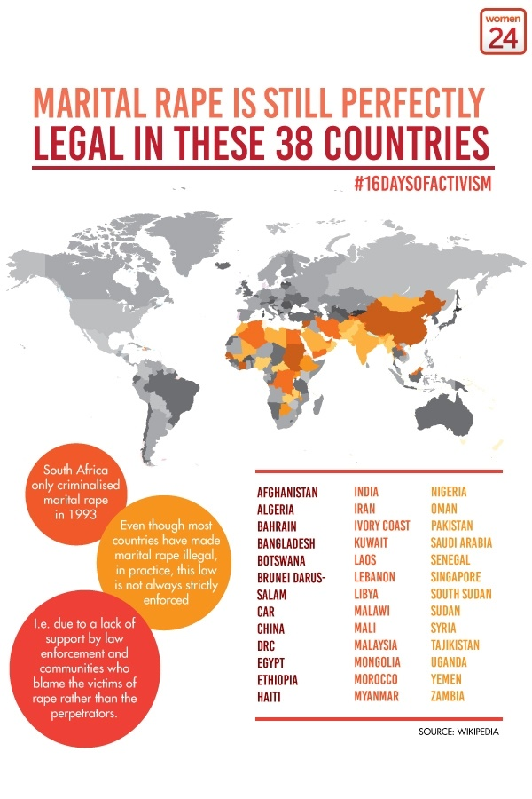

*MARITAL RAPE AND LAWS IN INDIA*

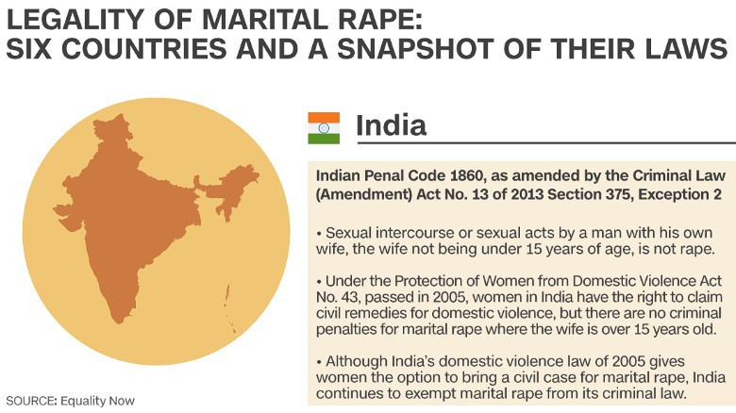

*Views Regarding Marital Rape in India*

Women’s rights activists, women’s organisations and the National Commission for Women have been demanding that marital rape be made a criminal offence as it is against the dignity of women who are forced to suffer the worst form of sexual violence silently within the four walls of their homes.

* A 2011 study by the International Center for Research on Women found that one in five Indian men surveyed forced their wives into sex and that two-thirds of women surveyed said their husbands forced them into sex. Thus, leaving marital rape out of the Indian penal code is to essentially say that women will never be seen as equals in India.
* The age limit of 15 years above which marital rape is not an offence is inherently problematic, as normally sex with a girl up to the age of 18 is an offence regardless of consent. The exemption given to marital rape, as Justice Verma noted, “Stems from a long out-dated notion of marriage which regarded wives as no more than the property of their husbands”. According to Advocate Gopal Subramaniam, who was co panellist on the Justice Verma Committee report, Basically, Section 375 (2) of the IPC allows men to rape their minor wives, and because marital rape isn’t yet a crime in India, but raping a minor is a statutory offence, the institution of marriage gets precedence over the health and well being of a girl child, just because she has been married off well before the legal age of marriage and consent, 18.
* According to Anuja Shah, online senior [family therapist](http://timesofindia.indiatimes.com/topic/family-therapist)  at ePsyClinic, once married, men think that any sort of sex he indulges in with the wife is normal. They believe that even if he forces his wife to have sex, it cannot be called rape. Marital rape simply means that husband doesn't have sensitivity towards the wife.
* Priya Nanda, group director of social and economic development at the ICRW (International Centre for Research on Women) questions the Indian law stating that, “there are two yardsticks to define rape - rape of an unmarried woman and that of a married woman? Is it acceptable to discriminate a woman just because she is married to the man who raped her?”
* A non-government organisation – ‘Independent Thought’ filed a Writ Petition (PIL) before the Supreme Court of India seeking a declaration that the ‘Exception 2’ to Section 375 of the Indian Penal Code, is violative of Articles 14, 15 and 21 of the Constitution of India to the extent that it permits intrusive sexual intercourse with a girl child aged between 15 to 18 years only on the ground that she has been married.

Well, the Government seems to have a different stand on Marital Rape altogether.

* The Minister of State for Home Affairs Haribhai Parathibhai Chaudhary told the Parliament, in a written reply that there is no proposal to make it a criminal offence as the concept cannot be applied in the country where marriage is treated as a `sacrament or sacred'. “It is considered that the concept of marital rape, as understood internationally , cannot be suitably applied in the Indian context due to various factors, including level of education, illiteracy, poverty, myriad social customs and values, religious beliefs, mindset of the society to treat the marriage as a sacrament” as a response to a question by DMK's Kanimozhi who asked the home ministry whether the government will bring a bill to amend the Indian Penal Code to remove the exception of marital rape from the definition of rape; and whether UN Committee on Elimination of Discrimination Against Women had recommended to India to criminalize marital rape.
* Various men’s rights activists’ have fought against the Section 498A claiming that women are ‘misusing the law’, ‘misuse is reflected in the low conviction rate and high arrest rate’ and so on. They have succeeded in influencing various institutions of the state, which has now resulted in the complete dilution of the law.
* Women and Child Development Minister Maneka Gandhi’s Inconsistent remarks has faced serious criticisms. Answering a question in Rajya Sabha on March 10, she said, “It is considered that the concept of marital rape, as understood internationally, cannot be suitably applied in the Indian context due to various factors like level of education/illiteracy, poverty, myriad social customs and values, religious beliefs, mindset of the society to treat the marriage as a sacrament etc.” Her [previous outrage on marital rape](http://indiatoday.intoday.in/story/maneka-gandhi-marital-rape-violence-against-women-india/1/446799.html). “My opinion is that violence against women shouldn’t be limited to violence by strangers. Very often a marital rape is not always about a man’s need for sex; it is only about his need for power and subjugation. In such cases, it should be treated with seriousness,” she had said.

*ARE WE TO BLAME?*

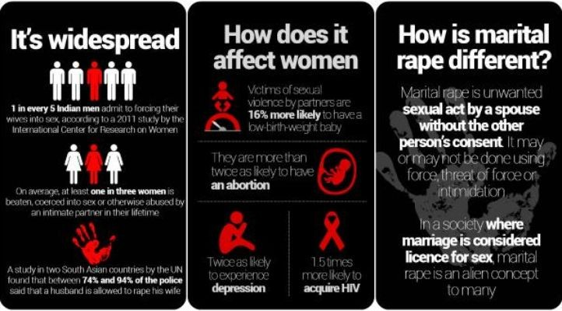

(Source: UN Women)

Sexual violence, including rape, falls within the larger ambit of domestic violence, but rape by husbands within marriages is a shadowy subject in India and exact numbers are hard to come by. Various studies suggest that the statistics provided by the NCRB, especially on crimes against women, are grossly underreported. Over [40% in 2005-06](http://rchiips.org/nfhs/NFHS-3%20Data/VOL-1/Chapter%2015%20-%20Domestic%20Violence%20(468K).pdf) and [30% in 2015-16](http://rchiips.org/NFHS/pdf/NFHS4/India.pdf) of married women in India have faced varied forms of domestic violence, and going by those numbers, not even 1% of married women facing domestic violence actually lodge complaints under Section 498A. In 2013,as per a UN Survey, a quarter of 10,000 men questioned in six Asia-Pacific countries, including India, admitted to having raped a female partner. The United Nations Population Fund and the ICRW found that 60% of men admitted to using violence—kicking, beating, slapping, choking, burning—to establish dominance. For Indian men, it was more about controlling women.

Gender stereotype that has always survived in our society has proved to be a disadvantage for women in many ways. An example of this is the failure to criminalize marital rape based on societal perception of women as the sexual property of men.

When women and girls are expected to assume a position as subordinate to men, their general health, including reproductive health, is negatively affected at all stages of the life cycle. Young girls may experience differential access to food and medical care during childhood and later dating violence or economically coerced sex during adolescence eventually followed by intimate partner violence, marital rape and dowry abuse at marital age. Effects of ‘Marital Rape’ remain a mark on the physical, psychological and most importantly **gynaecological on a woman.** The traditional thought of the society that it is impossible for husband to rape his wife because habitually the marriage vows to women to step down from say any over own body and sexuality and unfortunately here yet the husbands enjoy statutory exemption from rape against wives. There are evidences that firmly stand with the belief that women too, submit themselves to the atrocities willingly because of the assumption that “it is normal”.

*THE WAY AHEAD*

For an egalitarian society to prevail, it is highly necessary to encourage laws that enforce equableness and justice for all. Despite stringent laws against child marriage in India, the custom is still very much prevalent in our society and is been practised in a wide number more in the rural areas. Most of the cases go under the radar mainly due to lack of awareness which in turn is the result of lack of education. Well in the case of marital rape, the life of a girl child (minor – 15 years) is at stake when she becomes a mother. The health of both the child and the mother is at risk because 90% of new born tend to die at a very early age because of low weight and pre mature birth and it is more difficult for a minor to handle stress during pregnancy which results in depression, transfer of diseases such as HIV aids, single motherhood, violence that might end in suicide. The exemption thus, gives a way ahead for practises like these to continue for a minor at the age of 15, just because she is married. The saddest part in this scenario will be unawareness among girls that they are been raped and her rights over their own body is violated against her will.

It is true that effective laws should be established, starting with criminalizing marital rape. Cases cannot be won until the evidence is strong. It is important to give a voice to those in pain. There should be an immediate and a collective step on behalf of the society and the policy makers to take action combating the “Gender Stereotype” reality of the nation and help create a place for women where they too feel the freedom to live. The first step should be to diminish the thin line of inequality between what happens in public and in closed doors because the change starts at home. “TAKE ROOT DOWN, BEAR FRUIT UPWARD”.

*REFERENCES*

1. Gender roles and their influence on life prospects for women in urban Karachi, Pakistan: a qualitative study (2017, 2 November). *NCBI*. Retrieved from <https://www.ncbi.nlm.nih.gov/pmc/articles/PMC3208374/> on 11 August 2017.
2. UN Women - Facts and figures: Ending violence against women. Retrieved from <http://www.unwomen.org/en/what-we-do/ending-violence-against-women/facts-and-figures> on 7th August 2017.
3. Human Rights Watch-Q & A: Child Marriage and Violations of Girls' Rights (14th June 2017). Retrieved from [https://www.hrw.org/news/2013/06/14/q-child-marriage-and-violations-girls-rights on 2nd August 2017](https://www.hrw.org/news/2013/06/14/q-child-marriage-and-violations-girls-rights%20on%202nd%20August%202017).
4. Priyanka Rath, **Marital Rape and the Indian legal scenario. Retrieved from** [http://www.indialawjournal.org/archives/volume2/issue_2/article_by_priyanka.html. Date Accessed on13 August 2017](http://www.indialawjournal.org/archives/volume2/issue_2/article_by_priyanka.html.%20Date%20Accessed%20on13%20August%202017)**.**

# Sandhya Raghavan( 2017, July 12).Why rape victims don’t fight back. *India News*. Retrieved from <http://www.thehealthsite.com/body-mind-soul/why-rape-victims-dont-fight-back-k0717/> on 4 August 2017.

# Namita Bhandare( 2015, May 25). Behind closed doors: Marital rape in India. *Livemint.* Retrieved from [http://www.livemint.com/Politics/b6HcnmMqYadNzWAP05FbEO/Behind-closed-doors-Marital-rape-in-India.html on 4 August 2017](http://www.livemint.com/Politics/b6HcnmMqYadNzWAP05FbEO/Behind-closed-doors-Marital-rape-in-India.html%20on%204%20August%202017)

# Daily Bite (2017, August 10). By not seeing marital rape as crime, Supreme Court is doing a disservice to Indian Women. *Daily-O.* Retrieved from [http://www.dailyo.in/variety/supreme-court-marital-rape-india/story/1/18866.html on 11 August 2017](http://www.dailyo.in/variety/supreme-court-marital-rape-india/story/1/18866.html%20on%2011%20August%202017).

# Press Trust of India (2017, August 10). Marital Rape Not Penal Offence, Parliament Debated It: Supreme Court. *NDTV.* Retrieved from<http://www.ndtv.com/india-news/marital-rape-not-penal-offence-parliament-debated-it-supreme-court-1735713> on 10 August 2017.

# [Press Trust of India](http://www.india.com/author/press-trust-of-india/) (2015, April 24). Private bill on making marital rape a crime tabled in Rajya Sabha. *India.* Retrieved from <http://www.india.com/news/india/private-bill-on-making-marital-rape-a-crime-tabled-in-rajya-sabha-363151/>on 3 August 2017.

# Vasundhara Sirnate (Updated on 2016, September 06).When marriage is less than sacred. *The Hindu*. Retrieved from [http://www.thehindu.com/opinion/op-ed/when-marriage-is-less-than-sacred/article7315485.ece on 2 August 2017](http://www.thehindu.com/opinion/op-ed/when-marriage-is-less-than-sacred/article7315485.ece%20on%202%20August%202017).

# UNHCR – Gender Stereotypes/Stereotyping. Retrieved from [http://www.ohchr.org/EN/Issues/Women/WRGS/Pages/GenderStereotypes.aspx on 13 August 2017](http://www.ohchr.org/EN/Issues/Women/WRGS/Pages/GenderStereotypes.aspx%20on%2013%20August%202017).

# Kavitha Krishnan (2015 December). Rape Culture and Sexism in Globalising India. Retrieved from <http://sur.conectas.org/en/rape-culture-and-sexism-in-globalising-india/> on 4 August 2017.

# **Zena Tahhan (2016, September)** India: More than 34,000 cases of rape reported in 2015.*Aljazeera.* Retrieved from <http://www.aljazeera.com/news/2016/08/india-34000-cases-rape-reported-2015-160831140518208.html> on 9 August 2017

# Dr. Bhavish Gupta & Dr. Meena Gupta (2013 GJLS Vol. 1, No. 1)*.*Marital Rape: - Current Legal Framework in India and the Need for Change. Retrieved from [http://law.galgotiasuniversity.edu.in/pdf/issue2.pdf on 10 August 2017](http://law.galgotiasuniversity.edu.in/pdf/issue2.pdf%20on%2010%20August%202017).

# Bindu H Doddhatti (2017, August 11). The Dangerous, False Myth That Women Routinely Misuse Domestic Cruelty Laws. *The Wire.* Retrieved from <https://thewire.in/166766/section-498a-domestic-cruelty-laws/> on 11 August 2017.

1. India marital rape victims' lonely battle for justice (2015, May 26). *BBC*. Retrieved from [http://www.bbc.com/news/world-asia-india-32810834 on 12 August 2017](http://www.bbc.com/news/world-asia-india-32810834%20on%2012%20August%202017).
2. Darko Janjevic (2016, August 31). More than 34,600 reported rapes in India last year; six each day in Delhi. *DW.* Retrieved from [http://www.dw.com/en/more-than-34600-reported-rapes-in-india-last-year-six-each-day-in-delhi/a-19515397 on 8 August 2017](http://www.dw.com/en/more-than-34600-reported-rapes-in-india-last-year-six-each-day-in-delhi/a-19515397%20on%208%20August%202017)
3. Roli Srivastava (2016, 16 September) Marital rape: the statistics show how real it is. Retrieved from [http://www.thehindu.com/news/cities/mumbai/Marital-rape-the-statistics-show-how-real-it-is/article14410173.ece on 12 August 2017](http://www.thehindu.com/news/cities/mumbai/Marital-rape-the-statistics-show-how-real-it-is/article14410173.ece%20on%2012%20August%202017).
4. Indrani Basu (2016, 11 March). Marital Rape Can't Be A Crime In India: Maneka Gandhi. *Huffpost.* Retrieved from[http://www.huffingtonpost.in/2016/03/10/india-marital-rape*_*n_9435470.html on 13 August 2017](http://www.huffingtonpost.in/2016/03/10/india-marital-rape_n_9435470.html%20on%2013%20August%202017).
5. Monica Sarkar (2015 March 9)Marital rape: Why is it legal in India? *BBC*. Retrieved from [http://edition.cnn.com/2015/03/05/asia/marital-rape-india/index.html on 13 August 2017](http://edition.cnn.com/2015/03/05/asia/marital-rape-india/index.html%20on%2013%20August%202017)