|  |
| --- |
| RGICS  ISSUE BRIEF |
| (August 22, 2017)  Mahatma Gandhi National Rural Employment Guarantee Act : Current Challenges |

# **KEY MESSAGES**

* An independent study conducted by Rajedran Narayanan, says that the MGNREGA compensation is delayed by Centre or States in around 50% cases. Researchers claim that the compensation under MGNREGA was delayed either by the Centre or the State Governments in almost half of the 92 lakh cases which constitutes 57 per cent of the total compensation due to workers.

# The Central Government calculates the compensation amount only up to the point that the fund transfer order (FTO) is generated. The delay from then on until the money reaches the bank account of the worker is not captured.

## A CAG report regarding social audit in the rural job flagship scheme MGNREGA has found a number of loopholes including non-setting up of social audit units in eight states and shortage of resource persons to carry out the same in 14 other states.

* The gap calculated in terms of payment as compensation in BJP ruled states has been between 6-12 days, whereas in the non BJP ruled states, the estimate came up to 63-80 days as per the study conducted. Under the act, workers have to be mandatorily paid within 15 days.
* NREGA Sahayta Kendra, claims that in Lohardaga district of Jharkhand, about a thousand workers, who had not received their wage payments under MGNREGA, protested at the Kisko block office against the wage delay because of Aadhaar errors. Thus, there is noevidence to show that introducing Aadhaar identification into the employment guarantee Act will reduce corruption, while chances are it will increase the struggles of vulnerable citizens.
* Many State Governments including Haryana, Chattisgarh and Jharkhand have submitted an affidavit to the Supreme Court stating the reason behind the delay in wage payments as a result of lack of funds given by the Centre. Whereas, on the other hand, only 20% of the funds budgeted for 2017-18 are left for paying NREGA wages. Thus in four months, 80% of the programme funds have been utilized.

# **PART I. INTRODUCTION**

The Mahatma Gandhi National Rural Employment Guarantee Act (hereafter MGNREGA) is a law whereby any adult who applies for employment in rural areas has to be given work on local public works within 15 days. If employment is not given, an unemployment allowance has to be paid. The employment guarantee subject to a limit of 100 days per household per year. The main objective of NREGA is to protect rural households from poverty and hunger.

The Act, which guarantees up to 100 days of work to people in rural India, requires that workers receive their wages within 15 days of completing a week’s work cycle. Failing this, the government has to pay compensation to the workers. The compensation, over and above the due wages, is calculated at 0.05% of the unpaid wages for each day of delay. The provision is meant to deter delays in payments to rural workers who are often in need of immediate money.

 The BJP Manifesto had promised that the BJP Government will usher in “Achhe Din” for farmers and put an end to farm suicides. Increased public investment in agriculture and rural development, steps to enhance the profitability in agriculture by ensuring a minimum of 50 percent profits over the cost of the production, cheaper agricultural inputs and credit, introduction of latest technologies for farming and high-yielding seeds, linking of the MGNREGA to agriculture, a farm insurance scheme to take care of crop loss due to unforeseen natural calamities, strengthening and expansion of rural credit facilities, expansion of irrigation facilities, a price stabilisation fund to protect farmers from volatile world market prices, welfare measures for farmers above 60 years, small and marginal farmers and farm labour were among the promises.

Going by the answer given by the Ministry of Rural Development, during the budget session 2017 regarding lack of funds under MGNREGA,“ Mahatma Gandhi National Rural Employment Guarantee Scheme (MGNREGS) is a demand driven programme. The Central funds are released to the States/UTs on the basis of agreed to Labour Budget and taking into consideration the performance and the pace of utilization of available funds. During the current Financial Year 2016-17 (as on 02.02.2017) an amount of Rs. 43425.83 crore has been released to the States/UTs for implementation of MGNREGS which is the highest ever release since inception”.

# **PART III: KEY ISSUES**

* An independent study on 92 lakh MGNREGA transactions across 10 states has found that the central government does not calculate or pay any compensation for a part of the last-mile delay before money reaches bank accounts of rural worker. The data was taken from the MIS transactions of the Mahatma Gandhi National Rural Employment Guarantee Scheme, which is in the public domain. As per the study for the country as a whole, the study estimates, in the financial year 2016-17, if only 42.21% of the payment was generated within 15 days, the “delayed payment” in compensation for the entire country was Rs 519 crore. However, it insists, based on an analysis of sampled panchayats, the reported compensation not calculated came to an additional Rs 689 crore which means that 57 per cent of the payable compensation of the total compensation due to workers of the total compensation due to workers is not even being calculated by the Government.
* The Centre in its master circular of 2017-18 has said that Management Information System (MIS) is designed to calculate delays only up to the time the Fund Transfer Order (FTO), an electronic voucher which is generated by the MGNREGA software is generated by the State Government for the second time. The activists claim that according to Mahatma Gandhi National Rural Employment Guarantee Act (MGNREGA), wage delays and compensation for the delay has to be calculated till wages are to be deposited in the bank account of workers. Giving the example of how the delay happens, the study says, a week’s wage for a worker in 2016 was Rs 1002. Since this worker’s muster was closed on July 5, 2016, the official deadline before compensation starts getting calculated was July 20, 2016. In this case, the second signature on the FTO was made on September 24, 2016, i.e. 67 days after the official deadline. Based on this, at 0.5% per day delay, he would get Rs 34. However, the worker received the compensation in his bank account (credited date) on November 3, 2016. This amounted to an additional delay of 40 days, making the total delay in the payment of wages to 67 + 40 = 107 days. Yet, the “government does not even calculate the delay compensation for the additional 40 days' delay”, which came to Rs 20.
* Yogendra Yadav of the political outfit Swaraj Abhiyan, which is the petitioner in a case relating to implementation of MGNREGA in drought-hit states, said the unaccounted for delay has been seen more in non BJP-ruled states. “In Jharkhand it is nine days, Chhattisgarh 13 days, Karnataka 19 days, Rajasthan 12 days and Madhya Pradesh 6 days. According to the research, on an average the delay in crediting wages in the accounts of beneficiaries is 63 days across the ten states. It is interesting to note that while the delay in BJP ruled states vary from 6 to 12 days, it varies from 39 to 89 days in the non-BJP states.
* Going by the statement released by the Government, the Centre claims a big drop in the delay in payment of wages of rural job scheme workers in the first four months of 2017-18. The government has paid 86% wages of nearly one crore workers under the MNREGS scheme within 15 days in 2017-18 so far. "98 per cent payments are through the Electronic Fund Management System (e-FMS) and the Central Government has ensured timely release of funds and states have responded by strengthening the implementation machinery to provide timely payments," it said. However, Yadav alleged that almost 80 per cent of the total funds allocated for MGNREGA in 2017-18 has been exhausted in the first four months, while just around 48 per cent of approved labor budget for the year has been used by the states. On the other hand, Many State Governments including Haryana, Chattisgarh and Jharkhand have submitted an affidavit to the Supreme Court stating the reason behind the delay in wage payments as a result of lack of funds given by the Centre.
* Despite a series of Supreme Court orders that Aadhaar will not be made mandatory, with weary inevitability, earlier this month, the Ministry of Rural Development under the Aadhaar (Targeted Delivery of Financial and Other Subsidies, Benefits and Services) Act 2016 notified that citizens will have to “furnish proof of possession of Aadhaar” to access work under the Mahatma Gandhi National Rural Employment Guarantee Act (MGNREGA). NREGA Sahayta Kendra, in Lohardaga district of Jharkhand, about a thousand workers, who had not received their wage payments under MGNREGA, protested at the Kisko block office. Several of these cases of wage delay have actually been because of Aadhaar errors. Thus, there is noevidence to show that introducing Aadhaar identification into the employment guarantee Act will reduce corruption, while chances are it will increase the struggles of vulnerable citizens.

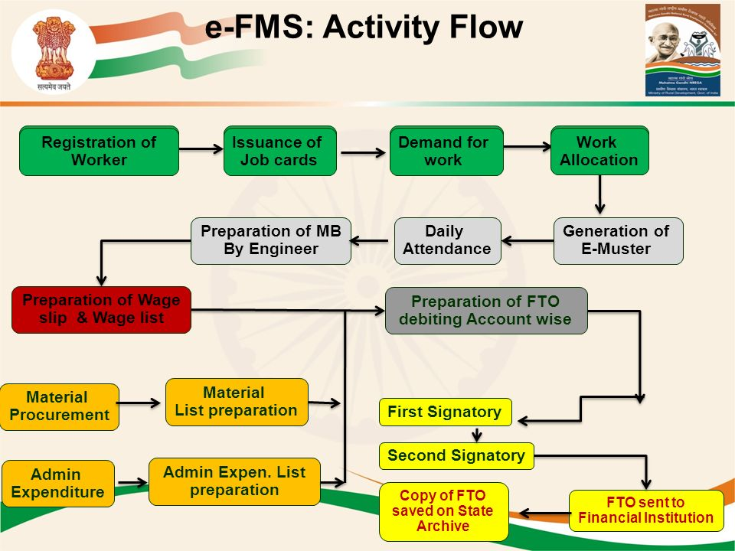

(Payments under MGNREGA through e-FMS/DBT)

**PART IV. BACKGROUND INFORMATION/REFERENCE DOCUMENTS**

# **Rajesh Pandathil & Kishor Kadam, “**UPA vs NDA: Check out these 7 charts to see how MGNREGA fared in 10 years” Firstpost. Available at <http://www.firstpost.com/business/upa-vs-nda-check-out-these-7-charts-to-see-how-mgnrega-fared-in-10-years-2608342.html> accessed on 21 August 2017.

# **Yamini Ayer,** “Three Years On, the Modi Government Still Has Gaping Holes in its Social Policy” *The Wire*. Available at <https://thewire.in/102937/social-policy-three-years-modi-government/> accessed on 19 August 2017.

# Is the highest ever MGNREGA allocation the biggest sham of #UnionBudget2017? Daily-O. Available at <http://www.dailyo.in/business/mgnrega-union-budget-2017-arun-jaitley-narendra-modi-bjp-congress-monumental-failure-allocation/story/1/15437.html> accessed on 19 August 2017**.ggest sham of #UnionBudget2017?**

# **Harish Damodaran**, “MGNREGA 2.0: Modi to spend a record Rs 60,000 crore on what was UPA flagship scheme” *The Indian* *Express*. Available at <http://indianexpress.com/article/india/india-news-india/mgnrega-nda-government-pm-modi-employment-days-mgnrega-3092201/> accessed on 18 August 2017.

# **Vishwa Deepak, “**Centre accused of MGNREGA ‘data fraud’, late release of funds”*National Herald.* Available at <https://www.nationalheraldindia.com/national/centre-accused-of-mgnrega-data-fraud-late-release-of-funds> accessed on 11 August 2017.

# **Shalini Nair, “**MGNREGA wages less than minimum farm wages in 15 states: Panel” The Indian Express. Available at <http://indianexpress.com/article/india/mgnrega-wages-less-than-minimum-farm-wages-in-15-states-panel-4743412/> accessed on 5 August 2017.

# **PTI**, “MGNREGA compensation delayed by Centre or states in around 50% cases: study” *Livemint.*Available at <http://www.livemint.com/Politics/wVH3yGzVq94juZiogGDEtL/MGNREGA-compensation-delayed-by-Centre-or-states-in-around-5.html> accessed on 5 August 2017.

### Rajiv Shah, “Delayed payment in e-transfer of NREGA wages: How Govt of India failed to pay 57% of compensation amount” Counterview. Available at <http://www.counterview.net/2017/08/delayed-payment-in-e-transfer-of-nrega.html> accessed on 10 August 2017

# **Express News Service,** “Govt does not calculate 57 per cent compensation dues to MGNREGA workers: Study” The Indian Express. Available at <http://indianexpress.com/article/india/govt-does-not-calculate-57-per-cent-compensation-dues-to-mgnrega-workers-4783060/> accessed on 11 August 2017.

CAG Report 2016, <http://www.cag.gov.in/sites/default/files/audit_report_files/Executive_Summary_12.pdf>

**Pratap Vikram Singh**, “Delay in compensation wrongly calculated under NREGA: Researchers” *Governance Now.* Available at <http://www.governancenow.com/news/regular-story/centre-wrongly-calculates-delay-compensation-under-nrega-researchers> accessed on 11 August 2017.

Prepared By Nancy D Cruz

Under the guidance of

Barkha Deva