**PROXY VOTING**

Proxy voting allows a Non-Resident Indian to appoint a nominee to exercise their franchise in place of him/her. The person declared as the proxy will be required to have all the documentation of the NRI in question to cast the vote. The elector must first register as a voter, following which he has to appoint a proxy who must be a registered voter in the elector’s constituency. Once that is done, the elector can inform the proxy of who he wants to vote for. Unlike service personnel who have the possibility to nominate a permanent proxy to vote in absence, Non-Resident Indians will have to nominate one proxy for each poll.

The Union government recently approved changes to electoral laws to allow Non- Resident Indians to vote in Assembly and Lok Sabha election from overseas.  This would be a historic move considering that the Representation of People Act of 1950 did not originally have provision for NRIs to vote. The Act disqualified NRIs from getting registered on the electoral rolls. In 2010, the Act was amended to include NRIs who were physically present in the country. With the latest change, NRIs will be able to exercise their rights through a “proxy”. The proposal to let NRIs overseas vote was taken up seriously by the Election Commission in 2014 when it received several requests — most prominently from Rajya Sabha MP and industrialist Naveen Jindal and the Ministry of Overseas Affairs.

Out of the total 11,846 registered overseas electors, as of January 2014,11,448 (96.64%) are registered in the State of Kerala and the rest 398 (3.36%) are registered in the States of Punjab (138), Tamil Nadu (112) Puducherry (56), Goa (27), Delhi (13), Haryana (12), Daman & Diu (9), Gujarat (7), Chandigarh & Madhya Pradesh (6 each), West Bengal (4), Chhattisgarh & Himachal Pradesh (2 each), and Andhra Pradesh, Rajasthan, Sikkim, Uttar Pradesh (1 each) but only 8 came ahead and voted.

At present, it remains unclear whether the Modi government would do away with the option of allowing NRIs to cast a “direct vote” and replace it entirely with the proxy vote system. But what is certain is that the RP Act will need to be amended once again. And this is where political players opposed to the cabinet’s proposal come in. Thus the manner in which the proxy will be selected remains unclear.

A little over 24,000 overseas Indians, who are entitled to cast their ballot in India, have registered themselves as voters. While there are no estimates on the number of overseas Indians eligible to vote in India, only 24,348 have registered with the poll panel. Out of these, 23,556 are from Kerala, 364 from Punjab and 14 from Gujarat, according to the data provided by the Commission. Data shows that only 10,000 to 12,000 NRIs have voted because they do not want to spend foreign currency to come to India and exercise their franchise. Advocate Haris Beeran, a lawyer who is part of the legal team representing Dr Vayalil at the Supreme Court, told Gulf News that proxy voting is a decision taken by the government for the time being and a better option like e-postal ballot could still be opted for in the future.

*Existing Legal Provisions*

RPA 1951: Amendment needed in sections

* 20A
* 50
* 60 (to include proxy voting)

Conduct of Elections Rules 1961: Amendment needed in sections

* 17 (postal ballot)
* 18
* 19
* 20 (1) & (2)
* 22
* 21 (1), (2), (3)
* 23-27

MIGRATION

As per the International Migration Outlook (2017), USA, Canada, UK, Australia and Germany continue to be the favoured destinations for Indian migrants. In terms of actual numbers, there has been a slight dip, except for migration to Canada and UK which has risen marginally.

1. Pakistan, which is India’s neighbour and political rival, records the second-highest number of Indian-born people outside of India, at **2**million, according to the U.N. data.
2. In terms of numbers, the U.S. is still the second-most popular destination for Indians, with nearly 2 million people who were born in India living there.
3. Numbers of Indian immigrants in the U.A.E. have also slowed dramatically in the past five years, rising only 20% from 2010 to 2015 compared with an increase of 126% between 2005 and 2010. The number of Indian men choosing to live abroad rose 18% from 8.5 million in 2010. The number of women doing the same thing rose 15% from 4.8 million in 2010 to 5.5 million in 2015.

**History of Proxy Voting In India**

The Constitution of India as well as Statutes recognise ‘Right to vote’ of the NRI as precious right. A person needs to be citizen of India of at least eighteen years of age, not otherwise disqualified by law and must be ordinary resident of the constituency to be enrolled as voter. A person can be enrolled in only one place in one constituency and has only one vote.  
  
However, in 2010, provision was made for Overseas Elector to get enrolled and vote in India. For exercise of his franchise he needs to be physically present in India. Practically, it meant no right at all and defeat of the said provision as larger number of Overseas Electors/NRIs were unable to divest the time and have to money to travel back to India to vote.  
  
Despite several millions of overseas citizens living aboard only a few got themselves registered to cast their votes as due to lack of awareness and difficulty of being physically present to cast vote. Accordingly, the doors of the Supreme Court were knocked for giving life to right to vote by providing alternative methods of voting. The Election Commission of India got a study conducted regarding feasibility of alternative methods of voting, which was accepted by the Government of India and appropriate amendments were stated to be considered.

Migration from India

The leading Indian states for outward labour migration, in 2014, included Uttar Pradesh, Bihar, Tamil Nadu, Kerala, Andhra Pradesh, West Bengal, Punjab, and Rajasthan. Together, these states accounted for over 80% of the migration from India at 678,644 outward migrants; Uttar Pradesh was the top contributor at 230,000 outward migrants. Preferred destination countries for Indian migrants are dominated by the GCC countries. The main factors leading to attractiveness of Middle East are economic strength, relative political stability and modern infrastructure. Saudi Arabia was the most popular destination for Indian migrants in 2015, with a total of 2.8 million Indians migrating to the country, due to ease of availability of jobs to unskilled labour along with higher wages compared with India.

* The states of Uttar Pradesh, Bihar, Haryana and Rajasthan accounted for over 370,000 emigration clearances in 2014. Bulk of these clearances were for the Middle East region. The migrants from these states are majorly unskilled and engage in jobs in the construction and retail industry.
* The states of Kerala, Andhra Pradesh, Telangana, and Tamil Nadu accounted for over 240,000 emigration clearances in 2014. Bulk of these clearances were for the EU, Australia, US, and the Middle East. The migrants from these states are majorly semi-skilled and engage in jobs in the healthcare, retail, and manufacturing industry.
* The states of Maharashtra and Karnataka accounted for over 34,000 emigration clearances in 2014. Bulk of these clearances were for EU and the US. The migrants from these states are majorly skilled and take up jobs in the information technology industry.
* The states of Gujarat and Punjab accounted for over 56,000 emigration clearances in 2014. Bulk of these clearances were for the US, Australia, Malaysia, and Singapore. The migrants from these states are majorly entrepreneurs, looking to move to other countries to set up their businesses.
* The states of West Bengal, Odisha, and North East India accounted for over 70,000 emigration clearances. Bulk of these clearances was for the Middle East, Australia, Singapore, and Malaysia. The migrants from these states are majorly semi-skilled and engage in jobs in the hospitality and retail industry.

Impact of migration on economy

India accounts for approximately 12% of the world's remittances and is the largest recipient of inward remittances, followed by China and Philippines. The origin countries for remittance flows to India correspond with the destination countries for Indian migrants. The top 3 countries namely, UAE, US, and Saudi Arabia together accounted for 49% of the remittances to India in 2014.

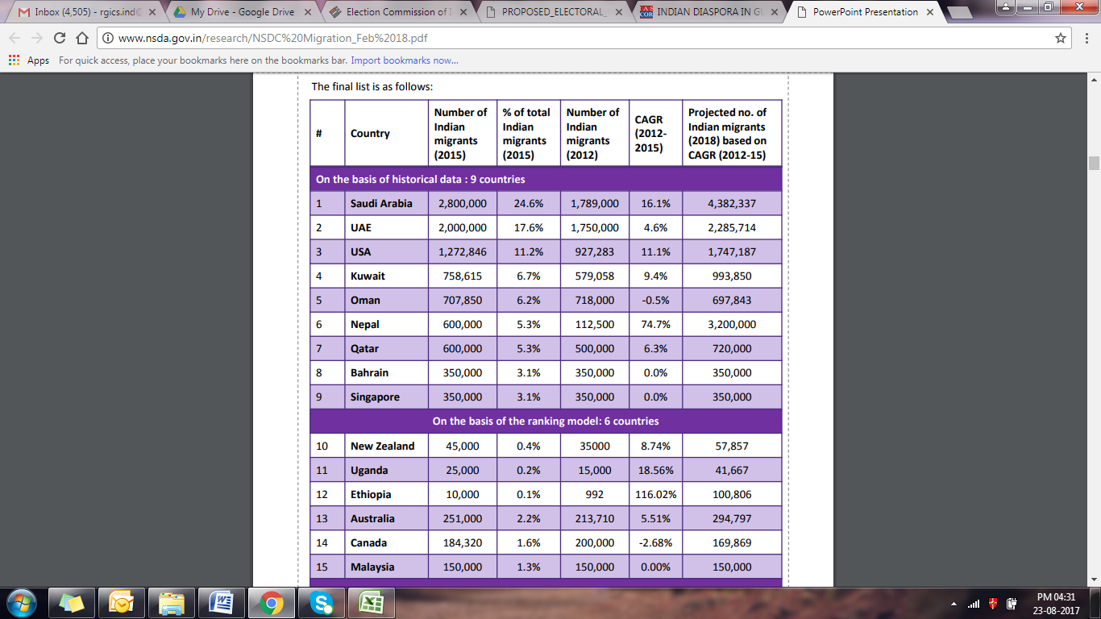

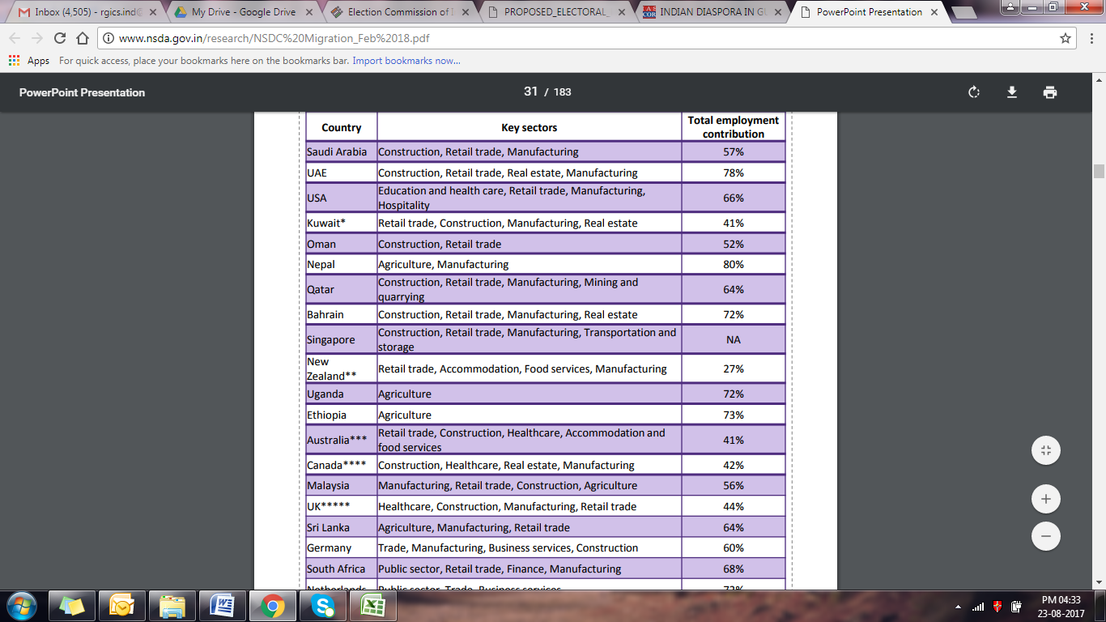

Migration happens internally between states in India and internationally to other countries Industries operating in various states (shaded in green) offer employment that is insufficient to cater to the large population in these states. This leads to lesser opportunities and a lower income for workers. States with lower levels of income and low job opportunities become source states. India is a major player in international migration and has a high number of individuals in the 16 – 34 age group that are most likely to migrate.

INDIAN DIASPORA IN GULF

The Indian expatriate population in the six GCC countries number close to six million - 5.94 million to be precise -and a huge chunk of them are Malayalees from Kerala, according to information available in the Indian ministries of Overseas Indian Affairs and External Affairs. The largest is in Saudi Arabia, numbering around two million. This is followed by 1.75 million in the UAE, 720,000 in Oman, 640,000 in Kuwait, 500,000 in Qatar, and 350,000 in Bahrain. Indian expatriates in the Gulf have a higher propensity to remit the money they earn. Gulf expatriates account for almost 30% of total remittances flowing back to India. The Gulf NRIs are generally less educated, relatively young and unmarried. They normally come from rural and comparatively poor economic background.

In the Middle East, one of India’s most distinct soft power assets is the diaspora and its role in buttressing a positive image of the country. Indian workers are often known for being peaceable, tolerant, and willing to work hard under harsh conditions. The Ministry of Overseas Indian Affairs, the agency dedicated to supporting India’s diaspora, states that the country’s tolerant, pluralistic society “in which people of different faiths, languages, ethnicities and political persuasions co-exist and thrive” is key to India’s positive migratory movements and labor mobility.

Indian migrants in the Gulf region can be divided into the following categories: unskilled labor employed in construction companies, municipalities agricultural farms domestic workers and as housemaid; skilled and semi-skilled workers employed as craftsman, driver, artisan and other technical workers; white-collar or professionals such as doctors, engineers, accountants, nurses, and paramedics, employed in government, private sectors and entrepreneurs.

* In the present context, Indian migrants to Gulf countries are facing various challenges in terms of exploitation by employers, unregulated private recruitment agencies involving in malpractices, and resultant increase in illegal migration. In order to improve the conditions of these migrants, the Government needs to envisage an emigration system that is not just regulating migration, but one which proactively manages it. Even while suggested measure to improve the lot of the Indian migrants in Gulf is undertaken by the Government, its needs to provide a pre-departure capacity-building and skills training to our unskilled labor, which go a long way in increasing their incomes. The average NRI death toll in the six Gulf countries (69.2 per 100,000) is much higher than in the rest of the world (26.5 per 100,000). The highest number of NRI deaths occurs in Saudi Arabia, Oman, UAE, and Kuwait (between 65 and 78 deaths per 100,000 Indians). Qatar's record, incidentally, is much better than these four countries.
* The death toll of Indian workers in the US and the UK is 80-90% lower when compared to the total death tolls in Saudi Arabia, Oman, UAE, and Kuwait. It can be attributed to the fact that Indians living in the West generally work in the technology and financial sectors (whereas most Indians go to the Gulf nations to work in high-risk jobs such as construction).

**The views of The Indian Diaspora regarding Proxy Voting**

A cross-section of Indian expatriates in the UAE welcomed Indian Government’s decision to give Non-Resident Indians (NRIs) the right to vote from abroad in elections in India through proxy voting but instead of majority of people consider postal ballet as a better option to promote regular voting patterns apart from the fact they are happy that they will be able to participate in the Indian elections. The migrant workers in Gulf countries have genuine interest in the politics back home. But they have to work overtime to support their families. So they stay away from time-consuming processes like electoral registration. There are chances that the registrations will increase if the Indian embassies provide them a facility for enrolment.

**Past Experiences with Proxy Voting**

Kerela: The move is likely to have a huge impact on elections in states like Kerala, which has nearly 10% of its population living abroad, helping its economy sustain through remittances but having no say in elections. For example, Kuttiadi, for long a fortress of the Communist Party of India (Marxist), produced the biggest surprise of the 2016 Assembly election when Parakkal Abdullah, of the Indian Union Muslim League, won the seat by a thin margin of 1,157 votes. The possible reason for his massive win could be Gulf-based voters who helped win who flew down on Election Day to cast votes. The expected constituencies that would be affected are: Nadapuram (CPM), Perambra (CPM), Kuttiadi (IUML), Palakkad (INC) and Varkala (CPM). The state also needs to make amendments in the Panchayati Raj Act and the election manual to enfranchise its 2.5mn-strong NRI community.

**Saudi Arabia:** The Indian diaspora in Saudi Arabia has a unique status among non-resident Indians (NRIs) who live all over the world. In terms of numbers, according to the Indian Embassy in Riyadh, there are 2.96 million of us living and working in the Kingdom. Major Indian communities residing are the Keralites, Hyderabadis, Biharis, UP-wallahs, Tamilians and Maharashtrians

Demands by the NRI Community

* There should be a separate section in the Ministry of Overseas Indian Affairs to look after the welfare of NRIs from Saudi Arabia.
* There is need for a social security scheme for returning Indians after their superannuation and of medical insurance as NRIs need more support from their government.
* The Pravasi Bharatiya Bima Yojana (PBBY), a compulsory insurance scheme for overseas Indian workers having ECR passports, covers death, permanent disability, medical needs, litigation etc. but it should also be extended to cover non-emergency situations for a larger group of NRIs.
* The Direct Admission of Students Abroad (DASA) scheme in which admissions are based on SAT, GMAT or GRE scores cater to students entering mainly technical education. A quota is needed in disciplines such as medicine and management studies as well.

**Isreal:** There are about 80-90 thousand Jews who have migrated from India since Independence from areas around Mumbai, Cochin and recently from the North East. Some of these communities have preserved their cultural moorings. For example, some of the Jews from Mumbai speak Marathi and celebrate Ganesh Utsav.

Then there are 8,000-10,000 nurses from Kerala who work for elderly care. About 500 students from India study in Israeli universities. And about 30-40 Gujarati families in trading in diamonds live in Israel.

**INDIAN DAISPORA IN USA**

The Indian diaspora in the United States is a hugely diverse community. Although it is dominated by Hindi and Gujarati-speaking groups, communities of [Hindus](https://en.wikipedia.org/wiki/Hindu), [Christians](https://en.wikipedia.org/wiki/Christianity_in_India), [Muslims](https://en.wikipedia.org/wiki/Islam_in_India), [Sikhs](https://en.wikipedia.org/wiki/Sikhs), [Jains](https://en.wikipedia.org/wiki/Jainism" \o "Jainism), [Buddhists](https://en.wikipedia.org/wiki/Buddhists), [Parsis](https://en.wikipedia.org/wiki/Parsis" \o "Parsis), and [Jews](https://en.wikipedia.org/wiki/Jews) from India have established their religions in the United States. According to 2012 [Pew Research Center](https://en.wikipedia.org/wiki/Pew_Research_Center), 51% Consider themselves [Hindus](https://en.wikipedia.org/wiki/Hindus), 20% as [Christians](https://en.wikipedia.org/wiki/Christians) (Protestant 11%, Catholic 5%, other Christian 3%), 14% as [Unaffiliated](https://en.wikipedia.org/wiki/Atheism), 10% as [Muslims](https://en.wikipedia.org/wiki/Muslims), 5% as [Sikh](https://en.wikipedia.org/wiki/Sikh), as [Jain](https://en.wikipedia.org/wiki/Jain). Unaffiliated is generally those who were raised as Hindus but aren't really practicing in the traditional sense.

The Indian American community is rapidly emerging as a political force and also helping to promote a better India. It has benefited India by transferring money, investments and sharing knowledge. In 2014, India was the largest source of new immigrants to the United States and the second largest source of total immigrants. Providing over 147,000 new immigrants in a single year, India was a bigger source than China (about 132,000) and Mexico (about 130,000). These latest additions raised the total India-born population to 2.2 million, making it the second largest foreign-born group in the United States (after Mexicans). Indian immigrants are widely dispersed across the country, but the largest numbers are in California, New Jersey, and Texas. By metropolitan area, the New York City area has the largest Indian immigrant population, followed by Chicago and San Jose, CA.

In terms of employment, even though it constitutes less than one percent of the total American population, it accounts for about ten percent of all doctors and more than five percent of scientists, engineers and IT professionals in the country. Indian Americans are also a relatively young population.

Contemporary Indian immigration flows to the United States have been shaped by temporary admissions for skilled workers and students, and as a consequence high-skilled individuals are overrepresented among the India-born population in the United States relative to India’s national population, the U.S. foreign-born population, and the U.S. general public. Indians entered the United States 1.8 million times as temporary workers and 819,000 times on student visas during the decade from fiscal year

Proxy Voting

The Global Organisation of People of Indian Origin welcomed the recent decision of the Union Cabinet to extend proxy voting to overseas Indians. Community leaders like Stephen favoured in person voting at Indian diplomatic missions abroad, so as to prevent misuse of proxy voting. However, election commission officials noted that such a move could have logistical problem. But they assured Indian Americans that they would discuss their feedback and concerns with their senior leadership.

“We would prefer direct voting, instead of proxy voting. GOPIO has also suggested that a proper representation must be provided to NRIs in the Indian Parliament. “One option could be by abolishing the reserved seats for Anglo-Indians since they are already well integrated settled in the Indian society and those seats are reserved for the unrepresented Indian citizens living outside India,” Abraham said.

**POLICY RECOMMENDATIONS BY DAISPORAS**

* United Arab Emirates and Saudi Arabia depend heavily on migrant workers for development, but do not have a formal immigration policy in place. Thus, migrant workers remain as temporary migrants, with no rights of permanency or citizenship, or opportunity to integrate. With the increasing local youth population and their aspirations, the host countries have to deal with the twin and often contradictory objectives of growing expectations of the local youth and ensuring social and economic development. Their problem is compounded by the fact that their youth lacks the skills and the training required to fulfil labour demand. Despite efforts at induction of local youth, these countries would continue to depend heavily on migrant workers for their development, and “therefore (migration) remains a critical public policy challenge
* Two other countries—the US and Australia—initially practised discriminatory policies towards non-whites, but over the years have designed their immigration policies in such a way as to ensure an inflow of a pool of professional and qualified migrants, offering them opportunities to integrate into the local society. According to the authors, their immigration policies have revolved around the issues of economic growth and national identity.
* States also try to engage its diaspora in developmental projects such as village development projects in Punjab which have been quite successful. In turn, the diaspora uses its influence to get favours from the state in setting up schools, hospitals, and colleges. It also expects the state to take up issues of their interest. The Malayali non-residential Indian (NRI) organisations, for instance, have pressed for issues like compensation for the Kuwait war, compensation for the relatives of *pravasi* dying in foreign land, and so on. Punjab has enacted legislations for compulsory registration of NRI marriages, amended legislation relating to encroachment of land belonging to NRIs, etc. Diaspora may also be used as a tool for “soft diplomacy” as in the case of the India–US Civil Nuclear Cooperation Agreement (p 124). The government recognises its diaspora’s achievements and contributions through conferring the Pravasi Bharatiya Sam
* Though voting rights were granted to NRIs to involve them in general elections, only a small number turned up to cast their vote suggesting that it may not be feasible for the NRIs to physically return to the state to cast their vote. Similarly, providing Overseas Citizens of India (OCI) status to People of Indian Origin (PIOs) may not lead to participation of PIOs in the political process directly as “OCI is not tantamount to dual citizenship”. On contesting elections or supporting political parties, NRIs and return migrants in Kerala have been elected to the state legislative assembly and have also represented the state in the parliament. Gujarati Diaspora actively supports the political parties that contest state elections. This is a result of their financial capacity, cultural and ideological leanings, and the state’s governance, that provide them “high visibility” in the state’s political space.

Voting pattern

There are approximately 10 million Indian citizens currently residing outside India as per the data compiled by the Ministry of External Affairs. These numbers have the potential to affect the election results if NRIs do vote in large numbers. With 10 million Indian citizens staying abroad, and with 543 Lok Sabha constituencies, it comes to an average of 18000 such voters per constituency. These additional votes, if polled, will have a significant impact on the result.

1. Bihar was the first state to allow NRI proxy voting in 2015. Despite the landslide victory for the Nitish Kumar-Lalu Yadav's Grand Alliance and decimation of the BJP, but the Diaspora gave a mixed response to the outcome. They preferred Nitin Kumar- BJP alliance for the State and the Centre in future.
2. Most migrant workers, who returned back during the State Assembly elections 2017 of UP, seem not to expect UP to miraculously yield jobs. Because of the despair across India, however, they find the BJP pitch tough to accept. Joblessness in UP is not just about lack of jobs in UP; it is also about lack of jobs outside UP too.
3. According to the latest figures of the World Bank, at US$ 69 billion a year, India is the biggest beneficiary of remittances. And more than half of this comes from the Middle East, not from North America or Europe. NRIs in America send only US$ 10.96 billion and those from the UK, US$ 3.63 billion. Out of all the remittances India receive; about US $ 15 billion are the earnings of the people from Kerala in the Middle East - most of them low-wage labourers and semi-skilled workers. Barring a handful of occasions, many incidents in the recent past have shown that the labourers are left to themselves when they are in serious trouble.  Neither the Centre nor the State have done anything to provide the returnee migrants with some alternatives.

