CRIMINALISING MARITAL RAPE 

( <http://kathmandupost.ekantipur.com/news/2016-10-25/more-than-laws-needed.html> )

*Introduction*

**Rape** is one of the most common crimes against **women** in **India**. While sanctions applicable to rape outside of marriage have been secured in India recently , law continues to victimize married women [by not recognizing marital rape as a criminal offence](http://www.indialawjournal.org/archives/volume2/issue_2/article_by_priyanka.html). During the recent criminal law amendment ordinance, the official reason for not making any changes to this marital rape law was that it would weaken the institution of marriage. Women’s rights activists have unanimously condemned the reason stated above by criticizing the government for ignoring the right of a woman to have complete control over her body and decisions even after marriage in the name of preserving traditional moral standards. Thus, it is no wrong to state that the categorisation of marital rape as a criminal offense is being viewed as a threat to the traditional view of marriage and a husband's sacramental superiority over his wife*What is Marital Rape?*

Marital Rape refers to unwanted intercourse by a man with his wife obtained by force, threat of force, or physical violence, or when she is unable to give consent. Marital rape could be by the use of force only, a battering rape or a sadistic/obsessive rape. It is a non-consensual act of violent perversion by a husband against the wife where she is physically and sexually abused.

Section 375 of Indian Penal Code, 1860 in India which has been under amended in the year 2013 defines rape and also prescribes its punishment whereas the Exception to S. 375 states*:*“Sexual intercourse by a man with his own wife, the wife not being under fifteen years of age, is not rape.” This section clearly creates two categories of persons: married women and unmarried women. It denies the protection of rape laws to the former, thus it prima facie violates Article 14 of the Indian Constitution.

In today’s world, the idea that a woman (wife) has to have sex with her husband irrespective of her will, consent, health, etc, is absolutely acceptable. Although, there are many legislations and enactments passed in India in regard to violence against woman in her own house like laws against dowry, cruelty, domestic violence and female infanticide. But when it comes to marital rape, the laws are silent.

. What caused the crises is the widely accepted norm of behaviour for men and women across the world and this is perpetuated by a highly gendered process of socialization which begins almost from birth- when we choose the colour blue for boy and pink for a girl. . A wife’s role has traditionally been understood as that of a homemaker. Sex has been treated as obligatory in a marriage and taboo outside it... It is essential that the interests of women need to be progressed in the matter of marital rape.

*International Standard*

According to UN Women’s 2011 Progress of the World’s Women: In Pursuit of Justice report, marital rape is a criminal offence in about 52 countries, including the United States, the United Kingdom, Canada, France, Mauritius, Thailand and neighbouring Bhutan. The report said 127 countries do not explicitly criminalise rape within marriage.

*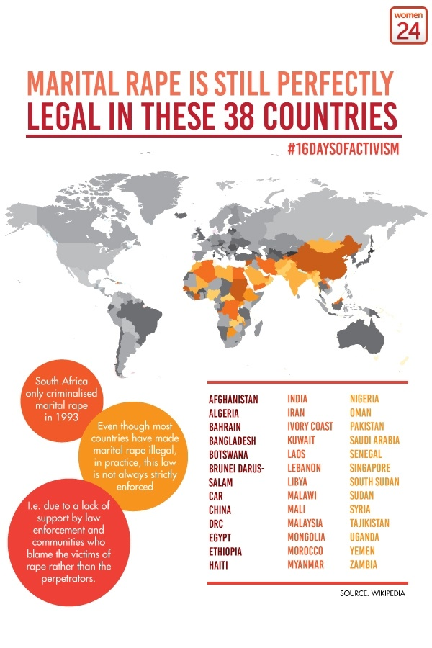*

*MARITAL RAPE AND LAWS IN INDIA*

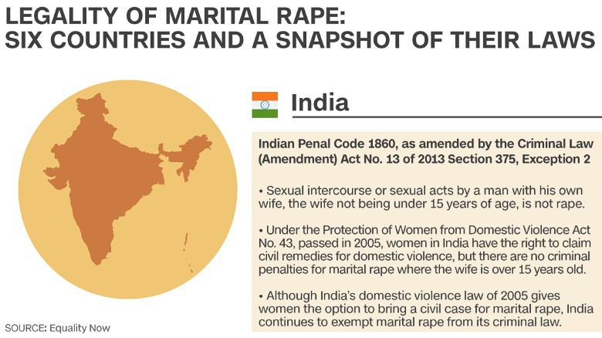

*Views Regarding Marital Rape in India*

Women’s rights activists, women’s organisations and the National Commission for Women have been demanding that marital rape be made a criminal offence as it is against the dignity of women who are forced to suffer the worst form of sexual violence silently within the four walls of their homes. Last year, the United Nations Population Fund and the International Centre for Research on Women surveyed more than 9,200 men across seven Indian states. “One-third of them admitted to having [forced a sexual act on their wives](http://www.icrw.org/sites/default/files/publications/Masculinity%20Book_Inside_final_6th%20Nov.pdf" \t "_blank), while 60 percent said they’d used some form of violence to assert dominance over their partners”.

The other major aspect pointed out is the age limit of 15 years above which marital rape is not an offence is inherently problematic, as normally sex with a girl up to the age of 18 is an offence regardless of consent. The exemption given to marital rape, as Justice Verma noted, “Stems from a long out-dated notion of marriage which regarded wives as no more than the property of their husbands”. According to Advocate Gopal Subramaniam, who was a co panellist on the Justice Verma Committee report, Basically, Section 375 (2) of the IPC allows men to rape their minor wives, and because marital rape isn’t yet a crime in India, but raping a minor is a statutory offence, the institution of marriage gets precedence over the health and well being of a girl child, just because she has been married off well before the legal age of marriage and consent, 18.

A non-government organisation – ‘Independent Thought’ filed a Writ Petition (PIL) before the Supreme Court of India seeking a declaration that the ‘Exception 2’ to Section 375 of the Indian Penal Code, is violative of Articles 14, 15 and 21 of the Constitution of India to the extent that it permits intrusive sexual intercourse with a girl child aged between 15 to 18 years only on the ground that she has been married. On the contrary, various men’s rights activists’ have fought against the Section 498A claiming that women are ‘misusing the law’, ‘misuse is reflected in the low conviction rate and high arrest rate’ and so on. They have succeeded in influencing various institutions of the state, which has now resulted in the complete dilution of the law.

*Government Response*

The Government response to marital rape has been problematic. The Minister of State for Home Affairs Haribhai Parathibhai Chaudhary told the Parliament, in a written reply that there is no proposal to make it a criminal offence as the concept cannot be applied in the country where marriage is treated as a `sacrament or sacred'. “It is considered that the concept of marital rape, as understood internationally , cannot be suitably applied in the Indian context due to various factors, including level of education, illiteracy, poverty, myriad social customs and values, religious beliefs, mindset of the society to treat the marriage as a sacrament” as a response to a question by DMK's Kanimozhi who asked the home ministry whether the government will bring a bill to amend the Indian Penal Code to remove the exception of marital rape from the definition of rape; and whether UN Committee on Elimination of Discrimination Against Women had recommended to India to criminalize marital rape

Women and Child Development Minister Maneka Gandhi’s has faced criticism due to her inconsistent remarks. Her [previous outrage on marital rape](http://indiatoday.intoday.in/story/maneka-gandhi-marital-rape-violence-against-women-india/1/446799.html). “My opinion is that violence against women shouldn’t be limited to violence by strangers. Very often a marital rape is not always about a man’s need for sex; it is only about his need for power and subjugation. In such cases, it should be treated with seriousness,” she had said is contradictory to her recent claims regarding marital rape and domestic violence. Her answer to a question in the Parliament on March 10 was as follows:

"It is considered that the concept of marital rape, as understood internationally, cannot be suitably applied in the Indian context due to various factors like level of education/illiteracy, poverty, myriad social customs and values, religious beliefs, mindset of the society to treat the marriage as a sacrament etc.".

*?A STRATEGY TO CRIMINALIZE MARITAL RAPE*

*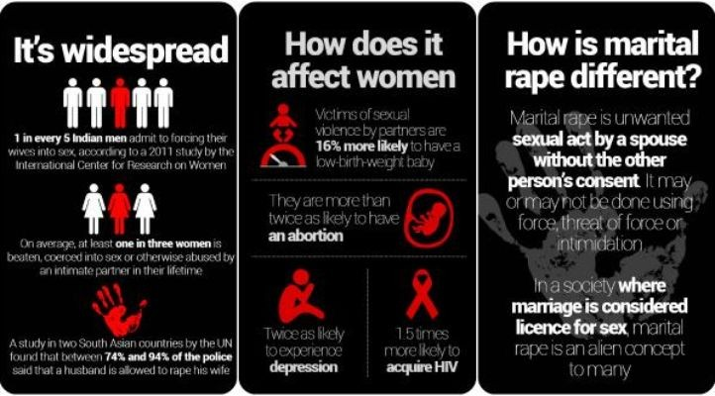*

(Source: UN Women)

Sexual violence, including rape, falls within the larger ambit of domestic violence, but rape by husbands within marriages is a shadowy subject in India and exact numbers are hard to come by. Various studies suggest that the statistics provided by the NCRB, especially on crimes against women, are grossly underreported. “Over [40% in 2005-06](http://rchiips.org/nfhs/NFHS-3%20Data/VOL-1/Chapter%2015%20-%20Domestic%20Violence%20(468K).pdf) and [30% in 2015-16](http://rchiips.org/NFHS/pdf/NFHS4/India.pdf) of married women in India have faced varied forms of domestic violence, and going by those numbers, not even 1% of married women facing domestic violence actually lodge complaints under Section 498A.” In 2013, as per a recent UN Survey, “a quarter of 10,000 men questioned in six Asia-Pacific countries, including India, admitted to having raped a female partner”. The United Nations Population Fund and the ICRW found that 60% of men admitted to using violence—kicking, beating, slapping, choking, burning—to establish dominance.

. \ , One of the main sufferers of marital rape are children.. Worldwide, studies show that health problems caused by marital rape include HIV and other sexually-transmitted infections, vaginal bleeding or infection, , pain during sex, chronic pelvic pain, and urinary tract infections. The physical violence associated with marital rape can also lead to complications during pregnancy, resulting in health problems for both women and their children. The age factor, of 15 years above will leave a deeper impact on the mental, physical and gynaecological health status of the child , The saddest part in this scenario will be unawareness among girls that they are been raped and her rights over their own body is violated against her will.

Effective laws should be established, starting with criminalizing marital rape. Both the society and the judiciary should come together and participate in raising awareness among the public that marital rape is a crime. The initiation should directed towards greater government investment in health, legal and rehabilitation services for people affected by domestic violence. *REFERENCES*

Gender roles and their influence on life prospects for women in urban Karachi, Pakistan: a qualitative study (2017, 2 November). *NCBI*. Retrieved from <https://www.ncbi.nlm.nih.gov/pmc/articles/PMC3208374/> on 11 August 2017.

UN Women - Facts and figures: Ending violence against women. Retrieved from <http://www.unwomen.org/en/what-we-do/ending-violence-against-women/facts-and-figures> on 7th August 2017.

Human Rights Watch-Q & A: Child Marriage and Violations of Girls' Rights (14th June 2017). Retrieved from [https://www.hrw.org/news/2013/06/14/q-child-marriage-and-violations-girls-rights on 2nd August 2017](https://www.hrw.org/news/2013/06/14/q-child-marriage-and-violations-girls-rights%20on%202nd%20August%202017).

Priyanka Rath, **Marital Rape and the Indian legal scenario. Retrieved from** [http://www.indialawjournal.org/archives/volume2/issue\_2/article\_by\_priyanka.html. Date Accessed on13 August 2017](http://www.indialawjournal.org/archives/volume2/issue_2/article_by_priyanka.html.%20Date%20Accessed%20on13%20August%202017)**.**

# Sandhya Raghavan( 2017, July 12).Why rape victims don’t fight back. *India News*. Retrieved from <http://www.thehealthsite.com/body-mind-soul/why-rape-victims-dont-fight-back-k0717/> on 4 August 2017.

# Namita Bhandare( 2015, May 25). Behind closed doors: Marital rape in India. *Livemint.* Retrieved from [http://www.livemint.com/Politics/b6HcnmMqYadNzWAP05FbEO/Behind-closed-doors-Marital-rape-in-India.html on 4 August 2017](http://www.livemint.com/Politics/b6HcnmMqYadNzWAP05FbEO/Behind-closed-doors-Marital-rape-in-India.html%20on%204%20August%202017)

# Daily Bite (2017, August 10). By not seeing marital rape as crime, Supreme Court is doing a disservice to Indian Women. *Daily-O.* Retrieved from [http://www.dailyo.in/variety/supreme-court-marital-rape-india/story/1/18866.html on 11 August 2017](http://www.dailyo.in/variety/supreme-court-marital-rape-india/story/1/18866.html%20on%2011%20August%202017).

# Press Trust of India (2017, August 10). Marital Rape Not Penal Offence, Parliament Debated It: Supreme Court. *NDTV.* Retrieved from<http://www.ndtv.com/india-news/marital-rape-not-penal-offence-parliament-debated-it-supreme-court-1735713> on 10 August 2017.

# [Press Trust of India](http://www.india.com/author/press-trust-of-india/) (2015, April 24). Private bill on making marital rape a crime tabled in Rajya Sabha. *India.* Retrieved from <http://www.india.com/news/india/private-bill-on-making-marital-rape-a-crime-tabled-in-rajya-sabha-363151/>on 3 August 2017.

# Vasundhara Sirnate (Updated on 2016, September 06).When marriage is less than sacred. *The Hindu*. Retrieved from [http://www.thehindu.com/opinion/op-ed/when-marriage-is-less-than-sacred/article7315485.ece on 2 August 2017](http://www.thehindu.com/opinion/op-ed/when-marriage-is-less-than-sacred/article7315485.ece%20on%202%20August%202017).

# UNHCR – Gender Stereotypes/Stereotyping. Retrieved from [http://www.ohchr.org/EN/Issues/Women/WRGS/Pages/GenderStereotypes.aspx on 13 August 2017](http://www.ohchr.org/EN/Issues/Women/WRGS/Pages/GenderStereotypes.aspx%20on%2013%20August%202017).

# Kavitha Krishnan (2015 December). Rape Culture and Sexism in Globalising India. Retrieved from <http://sur.conectas.org/en/rape-culture-and-sexism-in-globalising-india/> on 4 August 2017.

# **Zena Tahhan (2016, September)** India: More than 34,000 cases of rape reported in 2015.*Aljazeera.* Retrieved from <http://www.aljazeera.com/news/2016/08/india-34000-cases-rape-reported-2015-160831140518208.html> on 9 August 2017

# Dr. Bhavish Gupta & Dr. Meena Gupta (2013 GJLS Vol. 1, No. 1)*.*Marital Rape: - Current Legal Framework in India and the Need for Change. Retrieved from [http://law.galgotiasuniversity.edu.in/pdf/issue2.pdf on 10 August 2017](http://law.galgotiasuniversity.edu.in/pdf/issue2.pdf%20on%2010%20August%202017).

# Bindu H Doddhatti (2017, August 11). The Dangerous, False Myth That Women Routinely Misuse Domestic Cruelty Laws. *The Wire.* Retrieved from <https://thewire.in/166766/section-498a-domestic-cruelty-laws/> on 11 August 2017.

India marital rape victims' lonely battle for justice (2015, May 26). *BBC*. Retrieved from [http://www.bbc.com/news/world-asia-india-32810834 on 12 August 2017](http://www.bbc.com/news/world-asia-india-32810834%20on%2012%20August%202017).

Darko Janjevic (2016, August 31). More than 34,600 reported rapes in India last year; six each day in Delhi. *DW.* Retrieved from [http://www.dw.com/en/more-than-34600-reported-rapes-in-india-last-year-six-each-day-in-delhi/a-19515397 on 8 August 2017](http://www.dw.com/en/more-than-34600-reported-rapes-in-india-last-year-six-each-day-in-delhi/a-19515397%20on%208%20August%202017)

Roli Srivastava (2016, 16 September) Marital rape: the statistics show how real it is. Retrieved from [http://www.thehindu.com/news/cities/mumbai/Marital-rape-the-statistics-show-how-real-it-is/article14410173.ece on 12 August 2017](http://www.thehindu.com/news/cities/mumbai/Marital-rape-the-statistics-show-how-real-it-is/article14410173.ece%20on%2012%20August%202017).

Indrani Basu (2016, 11 March). Marital Rape Can't Be A Crime In India: Maneka Gandhi. *Huffpost.* Retrieved from[http://www.huffingtonpost.in/2016/03/10/india-marital-rape*\_*n\_9435470.html on 13 August 2017](http://www.huffingtonpost.in/2016/03/10/india-marital-rape_n_9435470.html%20on%2013%20August%202017).

Monica Sarkar (2015 March 9)Marital rape: Why is it legal in India? *BBC*. Retrieved from [http://edition.cnn.com/2015/03/05/asia/marital-rape-india/index.html on 13 August 2017](http://edition.cnn.com/2015/03/05/asia/marital-rape-india/index.html%20on%2013%20August%202017)