COVER STORY

The word ‘rape’ has been derived from the term ‘rapio’, which means ‘to seize’. Sexual violence occurs throughout the world. It includes rape and other sexual assault and defined as a forcible seizure, or the ravishment of a woman without her consent, by force, fear or fraud and involves coercive, non consensual sexual intercourse with a woman. In a social environment, it has been defined as an offence against woman, violating her dignity and self-respect and when it occurs within the four-walls of a matrimonial home, it reduces the woman to the status of an object used merely for sexual gratification.

World Health Organization (WHO) has defined "rape" (which in somewhat different terms is also the United States' federal meaning of rape) as *the penetration, no matter how slight, of the vagina or anus with any body part or object, or oral penetration by a sex organ of another person, without the consent of the victim*.

**The Rape Psychology**

Traditional gender roles prescribing female submission and male dominance are linked to rape. In Australia, Germany, and Japan, rates of violent sexual offenses were related to national levels of dominant masculinity (Neapolitan 1997). Studies in several countries have suggested that rigid gender roles and promotion of an ideology of male toughness are related to violence against women (Heise et al. 1994; Sanday 1981).

1. **Dealing with rejection:**  one of the reasons a man could rape a woman is to make up for the rejection he felt earlier by the opposite sex. By overpowering someone from the opposite sex the man can feel relieved of the shame of rejection.
2. **Feeling superior to women:** All men want to **feel superior** to women but some of them fall prey to low self confidence issues which forces them to believe that they are inferior to women.
3. **Regaining control:**  People who lack control over their own lives try to exert control over the less powerful ones they know. If a man felt he is not in control of his life and he wasn't brave enough to regain that control in a socially acceptable way then he might become a raper just to overpower a helpless victim and so feel in control.

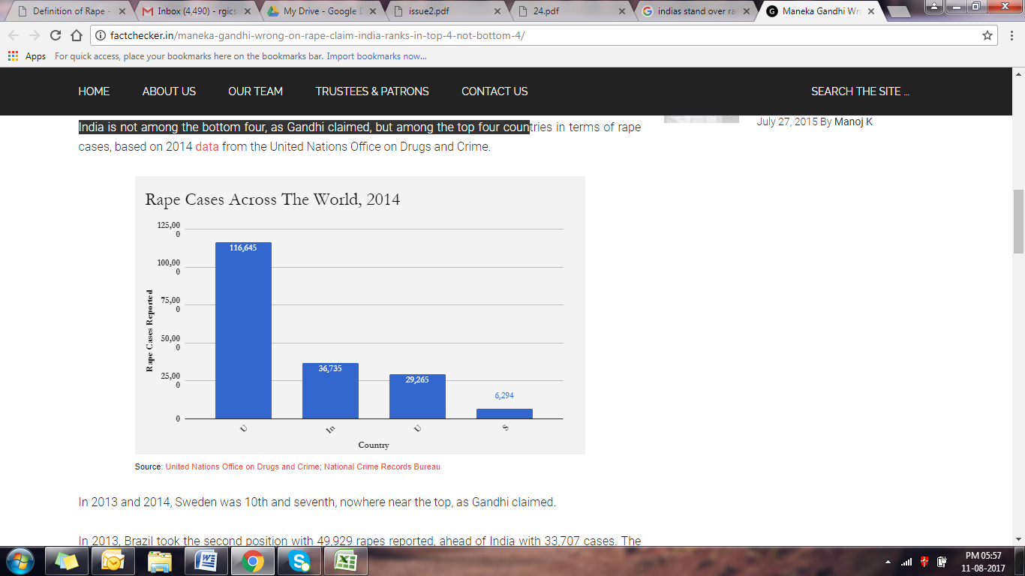

**Source: United Nations Office on Drugs and Crime; National Crime Records Bureau**

Rape Situation In India

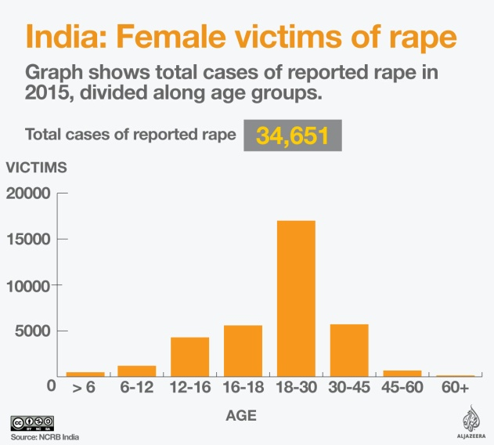

MARITAL RAPE IN INDIA

Marital Rape is the most common and repugnant form of masochism in the Indian society. It is usually defined as non-consensual/ forced sexual intercourse by the victim’s spouse. Some countries have criminalised marital rape while others still refuse to do so on the belief that such a thing is in fact impossibility and would be a blot on the sacred institution of marriage. In 2006, it was estimated that marital rape is an offence punished under the criminal law in at least 100 countries and India is not one of them.

Insert picture of countries Criminalising and not criminalising marital rape

In a recent interview the head of the United Nations Development Programme Helen Clarke had emphasized the need of the hour is to achieve gender equality and empower all women and girls. She emphasised the importance of “recognising domestic violence as an assault on women, everywhere”, and said it needed “a specific law with a specific purpose in order for people to take it seriously. Assaults against women like rape and sexual assault in the home have to be treated as crimes. Gender-based violence is blight on society, let alone on the woman.

Marital Rape and Laws in India